**The British College**

**KATHMANDU**

**Coursework Submission Coversheet**(individual coursework only)

**Faculty of Arts, Environment and Technology LBU Student Id:**

**77356818**

**For checking by the student:**

Please ensure all information is complete and correct and attach this form securely to the front of your work before posting it in a coursework collection box.

Award name: Bsc Hons in Computing

Module code: 15781-AUT-202110

Module name: Advance Database System (ADS)

Module run: 2024

Coursework title: Data warehouse Design and Development

Due Date: 20th Dec. 2024

Module leader: (In LBU): Jackie Campbell, Sanela Lazarevski

Module tutor: (In TBC): Dibya Tara Shakya

**TURNITIN** Checked: YES NO ***(please circle)***

Submission date& time: Date: 20th Dec. 2024 Time: Before noon

**Total Word Count:3353 Total Number of Pages (including this front sheet):47**

**In submitting this form with your assignment, you make the following declaration:**  
I declare, that the coursework submitted is my own work and has not (either in whole or part) been submitted towards the award of any other qualification either at LBU or elsewhere. I have fully attributed/referenced all sources of information used during the completion of my assignment, and I am aware that failure to do so constitutes an assessment offence.

Signed: Shambhu Prasad Sah Date: 20th Dec. 2024

**You are strongly advised to retain a second copy of your work in case of any query about the assignment.**

**For completion by the faculty:**

**This mark is provisional and subject to moderation and approval by the relevant examining board**

**Teacher's Feedback**

**Teacher's Signature: __________________________________ Date: _________________**

Table of Contents

Objective 3

Project Overview 3

Database 3

Data Warehouse 3

**Advantages of Data Warehouse** 5

Online Analytical Processing (OLAP) 5

Online Transaction Processing (OLTP) 6

Data Warehousing Schema 6

**1. Star Schema** 6

**2. Snowflake Schema** 7

Data Warehouse Concepts: Kimball Approach and Inmon Approach 9

**1. Kimball Approach (Bottom-Up Approach)** 9

**2. Inmon Approach (Top-Down Approach)** 10

Task 1: Data Mart (DM) star schema design 12

Task 2: Star Schema set up (DM environment) 12

Task 3: Extract, Transform and Load (ETL) script to populate the Star Schema (DM) with data 18

**Extraction** 19

**Transformation** 22

**Load** 36

Fact Table Data 46

# **Objective**

The primary objective of this assignment is to design and develop a robust system that ensures efficient data management and storage solutions. This includes creating a database structure and a data warehouse to support organizational needs, ensuring scalability, reliability, and performance optimization for decision-making processes.

# **Project Overview**

This project aims to integrate a structured database with a data warehouse for enhanced data analysis and reporting capabilities. The initiative involves:

1. **Database Design and Implementation:** Developing a relational database to handle transactional data efficiently.
2. **Data Warehousing:** Constructing a data warehouse to support analytical queries and long-term data storage.
3. **Data Integration:** Ensuring seamless data transfer and synchronization between the database and the data warehouse.
4. **Reporting and Analytics:** Providing tools and mechanisms for generating insights and reports to facilitate data-driven decisions.

# **Database**

A database is an organized collection of structured information, or data, typically stored electronically in a computer system. A database is usually controlled by a database management system (DBMS). Together, the data and the DBMS, along with the applications that are associated with them, are referred to as a database system, often shortened to just database.

# **Data Warehouse**

A data warehouse, also called an enterprise data warehouse (EDW), is an enterprise data platform used for the analysis and reporting of structured and semi-structured data from multiple data sources, such as point-of-sale transactions, marketing automation, customer relationship management, and more.

Data warehouses include an analytical database and critical analytical components and procedures. They support ad hoc analysis and custom reporting, such as data pipelines, queries, and business applications. They can consolidate and integrate massive amounts of current and historical data in one place and are designed to give a long-range view of data over time.

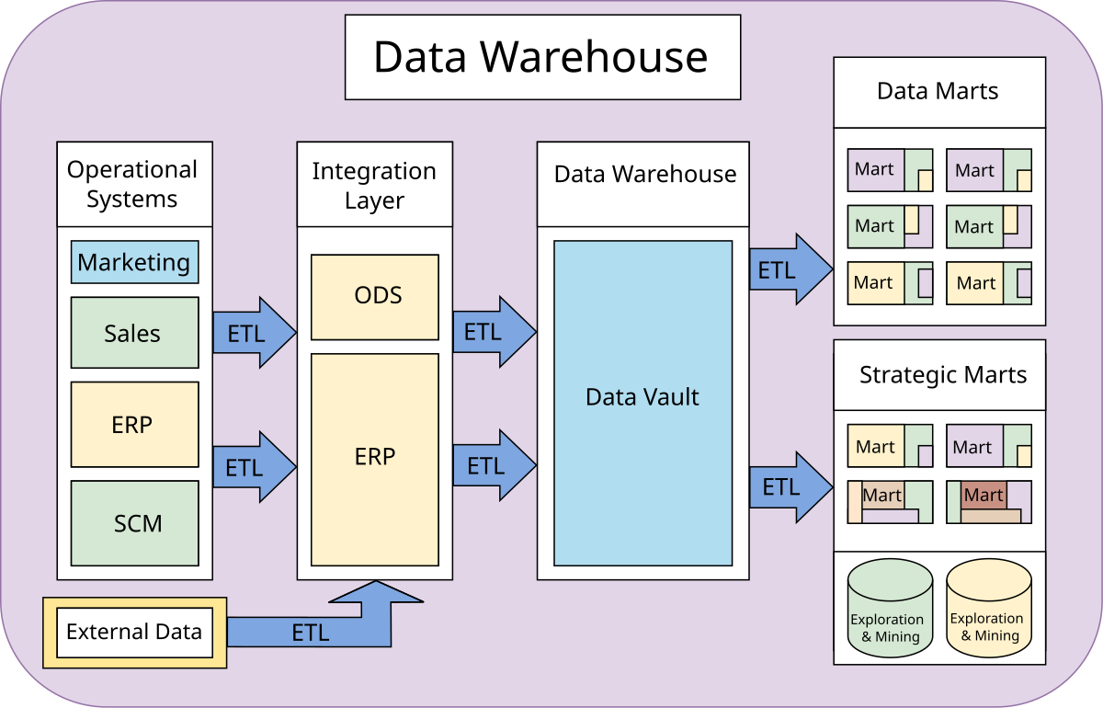

**Key Components:**

* **Fact Tables:** Contain quantitative data for analysis, e.g., sales data.
* **Dimension Tables:** Store descriptive attributes related to the facts, e.g., customer and product details.
* **OLAP (Online Analytical Processing):** Enabling multidimensional data analysis for business intelligence.

**Example Data Warehouse Structure:**

* Fact Table: Sales
  + Columns: Sale_ID, Product_ID, User_ID, Amount, Date
* Dimension Tables:
  + Product: Product_ID, Name, Category, Price
  + User: User_ID, Name, Location, Age Group
  + Time: Date, Month, Quarter, Year

## **Advantages of Data Warehouse**

1. Enhanced Decision-Making: Provides a centralized repository for data, enabling faster and more informed business decisions.
2. Improved Data Quality: Standardizes and consolidates data from multiple sources, ensuring consistency and accuracy.
3. Historical Data Storage: Retains historical data for trend analysis and forecasting.
4. Performance Optimization: Offloads analytical queries from operational databases, improving overall system performance.
5. Scalability: Supports growing data volumes and complex analytical queries as the organization expands.
6. Data Integration: Combines data from various sources, providing a unified view for comprehensive analysis.
7. Support for BI Tools: Facilitates integration with business intelligence tools for reporting and visualization.
8. Custom Analytics: Enables the creation of customized reports and analytics tailored to specific business needs.

# **Online Analytical Processing (OLAP)**

1. Definition: OLAP is a category of software tools that provide analysis of data stored in a database or data warehouse. It supports complex queries for multidimensional analysis, enabling users to view data from different perspectives.
2. Features:
   * Multidimensional views of data.
   * Fast execution of complex queries.
   * Support for slicing, dicing, drilling down, and rolling up data.
3. Applications: Business intelligence, financial reporting, trend analysis, and strategic planning.
4. Advantages:
   * Provides insights for decision-making through powerful analysis tools.
   * Handles large volumes of data efficiently.
   * Facilitates dynamic reporting and visualization.

# **Online Transaction Processing (OLTP)**

1. Definition: OLTP systems manage transactional data, supporting day-to-day operations. These systems are optimized for query speed and reliability in high-volume environments.
2. Features:
   * Handles a large number of short, online transactions.
   * Real-time data processing.
   * Supports insert, update, and delete operations.
3. Applications: Banking, retail, order management, and CRM systems.

**Advantages:**

* + Ensures data consistency and integrity.
  + Provides quick response times for transactional queries.
  + Enables reliable and secure data processing for operational use.

OLTP vs OLAP

|  |  |
| --- | --- |
| OLTP | OLAP |
| Involved day-to-day processing of information. | Involves historical processing of information |
| Useful in running the business. | Useful in analyzing the business. |
| Bases on Entity Relationship Model. | Based on Star Schema, snowflake, and fact constellation schema. |
| Provides primitive and highly detailed data. | Provides summarized and combined data. |
| Provides detailed and flat relational view of data. | Provides summarized and multidimensional view of data. |
| Provides high performance. | Highly flexible. |
| Used by operational staffs. | Used by decision makers. |
| The process is focused on the market. | The process is focused on the customer. |
| Database design is focused on the application. | Database design is focused on the subject. |

# **Data Warehousing Schema**

Data warehousing schemas are designed to optimize the storage, retrieval, and analysis of data within a data warehouse. Two common schema designs used in data warehousing are the **Star Schema** and the **Snowflake Schema**.

## **1. Star Schema**

The **Star Schema** is a simple, easy-to-understand data warehouse schema that consists of a central fact table and surrounding dimension tables. The fact table contains quantitative data that is the subject of analysis (such as sales data), while the dimension tables contain descriptive attributes related to the facts.

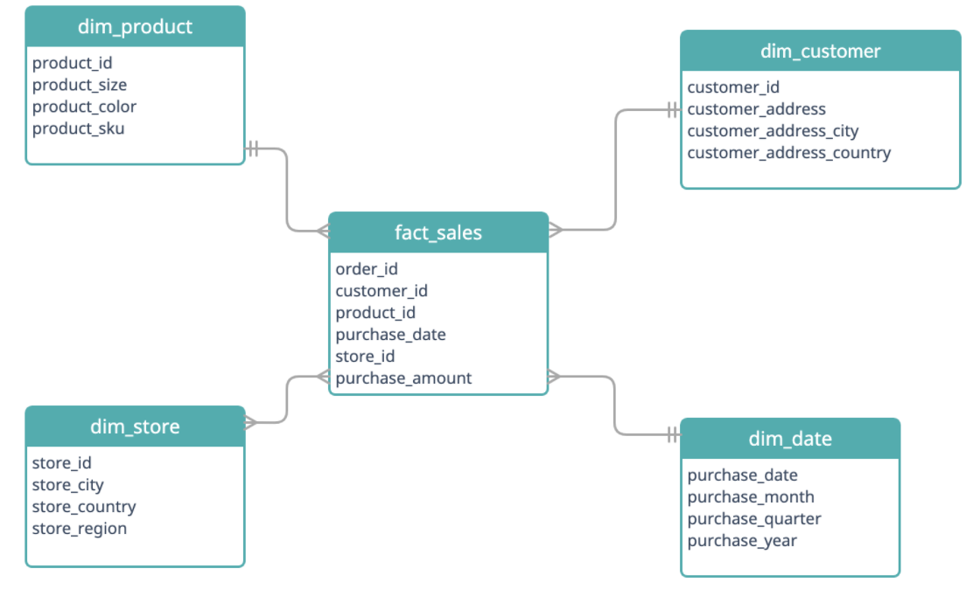

* **Structure**:
  + A central fact table contains primary key columns and measures (e.g., sales revenue, quantity sold).
  + Multiple dimension tables are connected to the fact table through foreign keys. These dimension tables describe various characteristics related to the facts (e.g., customer information, product details, time).
* **Advantages**:
  + Simplicity: The star schema is easy to understand and implement, making it suitable for reporting and analysis.
  + Performance: Since there are no complex joins (dimension tables are usually denormalized), query performance is improved.
  + Flexibility: Suitable for ad-hoc querying and business intelligence reporting.

## **2. Snowflake Schema**

The Snowflake Schema is an extension of the star schema where dimension tables are normalized into multiple related tables. This structure reduces redundancy and improves data integrity but can make querying more complex.

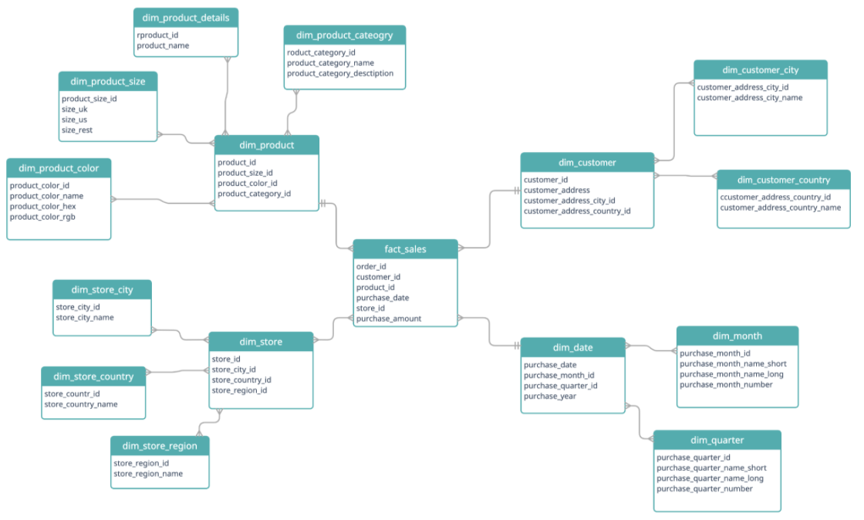

* **Structure**:
  + The fact table remains central, but dimension tables are normalized, breaking them into multiple related tables.
  + For example, a Products table could be split into Product_Categories and Product_Brands tables, with the Products table referencing these two tables through foreign keys.

• **Advantages**:

* Data Integrity: Reduces data redundancy by normalizing the dimension tables.
* Storage Efficiency: Less storage space is required compared to a star schema because of normalization.
* Data Consistency: Ensures consistency by reducing duplicate data entries.

• **Disadvantages**:

* Complexity: Querying can be slower and more complex due to multiple joins.
* Performance: Queries might be less performant compared to a star schema, especially in large data sets.

# **Data Warehouse Concepts: Kimball Approach and Inmon Approach**

Two prominent approaches to designing data warehouses are the **Kimball Approach** and the **Inmon Approach**. These methodologies guide how to structure data warehouses and how data marts are implemented.

## **1. Kimball Approach (Bottom-Up Approach)**

The **Kimball Approach** focuses on a **bottom-up** methodology, where data marts are created first for specific business processes or departments, and then integrated into a comprehensive data warehouse.

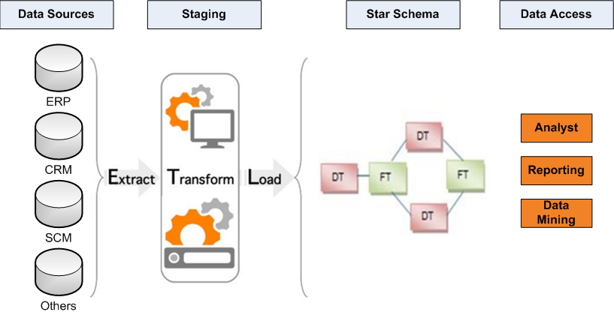

* **Key Features**:
  + **Dimensional Modeling**: The Kimball approach emphasizes **dimensional modeling**, which involves creating fact and dimension tables to support analytical queries. The fact tables contain business metrics (like sales data), while dimension tables contain descriptive attributes (like product or customer data).
  + **Data Marts**: Data marts are built for specific departments or business processes, such as sales, marketing, or finance. These data marts are then integrated into the data warehouse.
  + **User-Focused**: The Kimball approach is designed with ease of use in mind for end-users. It emphasizes making data accessible for business users through simplified dimensional models.
* **Advantages**:
  + **Faster Implementation**: Data marts can be implemented relatively quickly, providing immediate access to data for specific business areas.
  + **Business-Oriented**: The approach focuses on business needs, ensuring that data is structured in a way that is understandable and accessible for business users.
  + **Flexibility**: It allows for flexibility in designing individual data marts that meet specific business requirements.
* **Disadvantages**:
  + **Data Duplication**: There can be some redundancy in data marts since they are designed independently before integration.
  + **Integration Challenges**: When data marts are combined into the data warehouse, integrating them can be complex, especially if there is inconsistent data across marts.

## **2. Inmon Approach (Top-Down Approach)**

The **Inmon Approach** is based on a **top-down** methodology, where the data warehouse is developed first as a centralized repository, and then data marts are created for specific business processes.

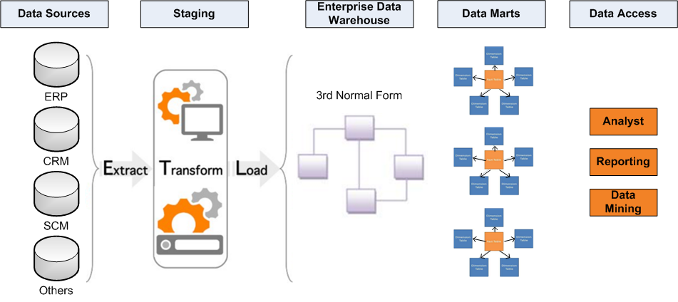

* **Key Features**:
  + **Enterprise Data Warehouse (EDW):** The Inmon approach starts by creating an enterprise-wide data warehouse that serves as a single source of truth. This warehouse contains all the organization's data, and data marts are created later for individual business processes.
  + **Normalized Data**: The data warehouse is typically built using a **normalized** structure, which minimizes redundancy and ensures data integrity.
  + **Centralized**: Data is centralized in one repository, which is then extracted and loaded into specific data marts for analysis.
* **Advantages**:
  + **Consistency**: The centralized data warehouse ensures data consistency across the organization.
  + **Comprehensive**: The enterprise data warehouse contains all organizational data, which can then be tailored into data marts.
  + **Data Integrity**: Normalization ensures high data integrity by minimizing redundancy.
* **Disadvantages**:
  + **Slow Implementation**: Building an enterprise data warehouse takes longer, and it may take time to see any results or access to data marts.
  + **Complexity**: The top-down approach can be more complex due to the need for a detailed, normalized data model.

# **Task 1: Data Mart (DM) star schema design**

According to my **KPI 3: Identify areas with crime hotspots,** I have identified these 5 report as follow:

* 1. Crime Distribution by Station/Region.
  2. Top Crime location ranking
  3. Crime severity by station/region
  4. Crime type concentration by area.
  5. Crime frequency by station and time period.

# **Task 2: Star Schema set up (DM environment)**

According to my reports, I have created the star schema as follow

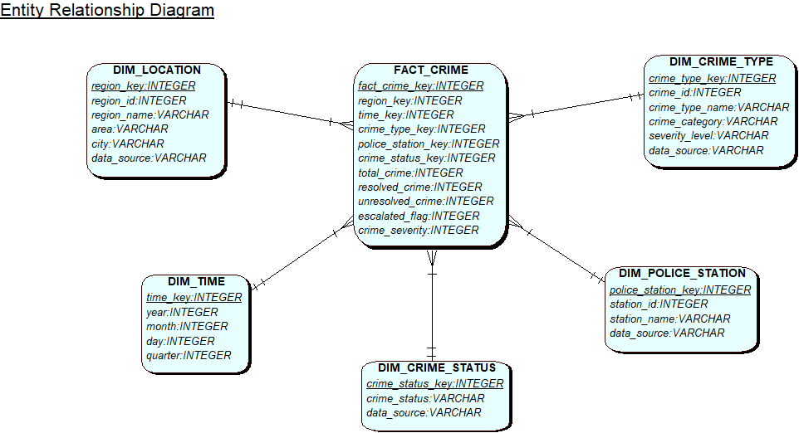

And the QSEE generated script is as follow   
  
--------------------------------------------------------------

-- Database creation Script

-- Auto-Generated by QSEE-SuperLite (c) 2001-2004 QSEE-Technologies Ltd.

-- Verbose generation: ON

-- note: spaces within table/column names have been replaced by underscores (_)

-- Target DB: SQL2

-- Entity Model :Entity Relationship Diagram

-- To drop the tables generated by this script run -

-- 'C:\Users\Shambhu\Downloads\script dim_drop.sql'

--------------------------------------------------------------

--------------------------------------------------------------

-- Table Creation --

-- Each entity on the model is represented by a table that needs to be created within the Database.

-- Within SQL new tables are created using the CREATE TABLE command.

-- When a table is created its name and its attributes are defined.

-- The values of which are derived from those specified on the model.

-- Certain constraints are sometimes also specified, such as identification of primary keys.

DROP TABLE FACT_CRIME;

-- Create a Database table to represent the "FACT_CRIME" entity.

CREATE TABLE FACT_CRIME(

fact_crime_key INTEGER NOT NULL,

total_crime INTEGER,

resolved_crime INTEGER,

unresolved_crime INTEGER,

escalated_flag INTEGER,

crime_severity INTEGER,

fk1_region_key INTEGER NOT NULL,

fk2_time_key INTEGER NOT NULL,

fk3_crime_type_key INTEGER NOT NULL,

fk4_police_station_key INTEGER NOT NULL,

fk5_crime_status_key INTEGER NOT NULL,

-- Specify the PRIMARY KEY constraint for table "FACT_CRIME".

-- This indicates which attribute(s) uniquely identify each row of data.

CONSTRAINT pk_FACT_CRIME PRIMARY KEY (fact_crime_key)

);

/*

DROP TABLE DIM_LOCATION;

-- Create a Database table to represent the "DIM_LOCATION" entity.

CREATE TABLE DIM_LOCATION(

region_key INTEGER NOT NULL,

region_id INTEGER,

region_name VARCHAR2(25),

area VARCHAR2(20),

city VARCHAR2(20),

data_source VARCHAR2(15),

-- Specify the PRIMARY KEY constraint for table "DIM_LOCATION".

-- This indicates which attribute(s) uniquely identify each row of data.

CONSTRAINT pk_DIM_LOCATION PRIMARY KEY (region_key)

);

DROP TABLE DIM_TIME;

-- Create a Database table to represent the "DIM_TIME" entity.

CREATE TABLE DIM_TIME(

time_key INTEGER NOT NULL,

year INTEGER,

month INTEGER,

day INTEGER,

quarter INTEGER,

-- Specify the PRIMARY KEY constraint for table "DIM_TIME".

-- This indicates which attribute(s) uniquely identify each row of data.

CONSTRAINT pk_DIM_TIME PRIMARY KEY (time_key)

);

DROP TABLE DIM_CRIME_TYPE;

-- Create a Database table to represent the "DIM_CRIME_TYPE" entity.

CREATE TABLE DIM_CRIME_TYPE(

crime_type_key INTEGER NOT NULL,

crime_id INTEGER,

crime_type_name VARCHAR2(20),

crime_category VARCHAR2(15),

severity_level VARCHAR2(8),

data_source VARCHAR2(15),

-- Specify the PRIMARY KEY constraint for table "DIM_CRIME_TYPE".

-- This indicates which attribute(s) uniquely identify each row of data.

CONSTRAINT pk_DIM_CRIME_TYPE PRIMARY KEY (crime_type_key)

);

DROP TABLE DIM_POLICE_STATION;

-- Create a Database table to represent the "DIM_POLICE_STATION" entity.

CREATE TABLE DIM_POLICE_STATION(

police_station_key INTEGER NOT NULL,

station_id INTEGER,

station_name VARCHAR2(20),

data_source VARCHAR2(15),

-- Specify the PRIMARY KEY constraint for table "DIM_POLICE_STATION".

-- This indicates which attribute(s) uniquely identify each row of data.

CONSTRAINT pk_DIM_POLICE_STATION PRIMARY KEY (police_station_key)

);

DROP TABLE DIM_CRIME_STATUS;

-- Create a Database table to represent the "DIM_CRIME_STATUS" entity.

CREATE TABLE DIM_CRIME_STATUS(

crime_status_key INTEGER NOT NULL,

crime_status VARCHAR2(10),

data_source VARCHAR2(15),

-- Specify the PRIMARY KEY constraint for table "DIM_CRIME_STATUS".

-- This indicates which attribute(s) uniquely identify each row of data.

CONSTRAINT pk_DIM_CRIME_STATUS PRIMARY KEY (crime_status_key)

);

*/

--------------------------------------------------------------

-- Alter Tables to add fk constraints --

-- Now all the tables have been created the ALTER TABLE command is used to define some additional

-- constraints. These typically constrain values of foreign keys to be associated in some way

-- with the primary keys of related tables. Foreign key constraints can actually be specified

-- when each table is created, but doing so can lead to dependency problems within the script

-- i.e. tables may be referenced before they have been created. This method is therefore safer.

-- Alter table to add new constraints required to implement the "FACT_CRIME_DIM_LOCATION" relationship

-- This constraint ensures that the foreign key of table "FACT_CRIME"

-- correctly references the primary key of table "DIM_LOCATION"

ALTER TABLE FACT_CRIME ADD CONSTRAINT fk1_FACT_CRIME_to_DIM_LOCATION FOREIGN KEY(fk1_region_key) REFERENCES DIM_LOCATION(region_key);

-- Alter table to add new constraints required to implement the "FACT_CRIME_DIM_TIME" relationship

-- This constraint ensures that the foreign key of table "FACT_CRIME"

-- correctly references the primary key of table "DIM_TIME"

ALTER TABLE FACT_CRIME ADD CONSTRAINT fk2_FACT_CRIME_to_DIM_TIME FOREIGN KEY(fk2_time_key) REFERENCES DIM_TIME(time_key);

-- Alter table to add new constraints required to implement the "FACT_CRIME_DIM_CRIME_TYPE" relationship

-- This constraint ensures that the foreign key of table "FACT_CRIME"

-- correctly references the primary key of table "DIM_CRIME_TYPE"

ALTER TABLE FACT_CRIME ADD CONSTRAINT fk3_FACT_CRIME_to_DIM_CRIME_TYPE FOREIGN KEY(fk3_crime_type_key) REFERENCES DIM_CRIME_TYPE(crime_type_key);

-- Alter table to add new constraints required to implement the "FACT_CRIME_DIM_POLICE_STATION" relationship

-- This constraint ensures that the foreign key of table "FACT_CRIME"

-- correctly references the primary key of table "DIM_POLICE_STATION"

ALTER TABLE FACT_CRIME ADD CONSTRAINT fk4_FACT_CRIME_to_DIM_POLICE_STATION FOREIGN KEY(fk4_police_station_key) REFERENCES DIM_POLICE_STATION(police_station_key);

-- Alter table to add new constraints required to implement the "FACT_CRIME_DIM_CRIME_STATUS" relationship

-- This constraint ensures that the foreign key of table "FACT_CRIME"

-- correctly references the primary key of table "DIM_CRIME_STATUS"

ALTER TABLE FACT_CRIME ADD CONSTRAINT fk5_FACT_CRIME_to_DIM_CRIME_STATUS FOREIGN KEY(fk5_crime_status_key) REFERENCES DIM_CRIME_STATUS(crime_status_key);

/*

--------------------------------------------------------------

-- End of DDL file auto-generation

# **Task 3: Extract, Transform and Load (ETL) script to populate the Star Schema (DM) with data**

ETL stands for extract, transform, and load and is a traditionally accepted way for organizations to combine data from multiple systems into a single database, data store, data warehouse, or data lake. ETL can be used to store legacy data, or—as is more typical today—aggregate data to analyse and drive business decisions.

Extract, transform, load (ETL) is a three-phase computing process where data is extracted from an input source, transformed (including cleaning), and loaded into an output data container. The data can be collected from one or more sources, and it can also be output to one or more destinations. ETL processing is typically executed using software applications, but it can also be done manually by system operators. ETL software typically automates the entire process and can be run manually or on recurring schedules either as single jobs or aggregated into a batch of jobs.

## **Extraction**

During data extraction, raw data is copied or exported from source locations to a staging area. Data management teams can extract data from a variety of different sources, which can be structured or unstructured.

In this step, the data is extracted from the source system PRCS and PS_Wales to the staging area. After the extraction, the data are being separated in good data and bad data by verifying the if there is any null value, incorrect data such as date, name, format and others. After the separation of data in good and bad, the bad data are treated to correct the date such as reported date is bigger than closed data, closed date were missing of which crime case is closed and letter of words were not in proper format.

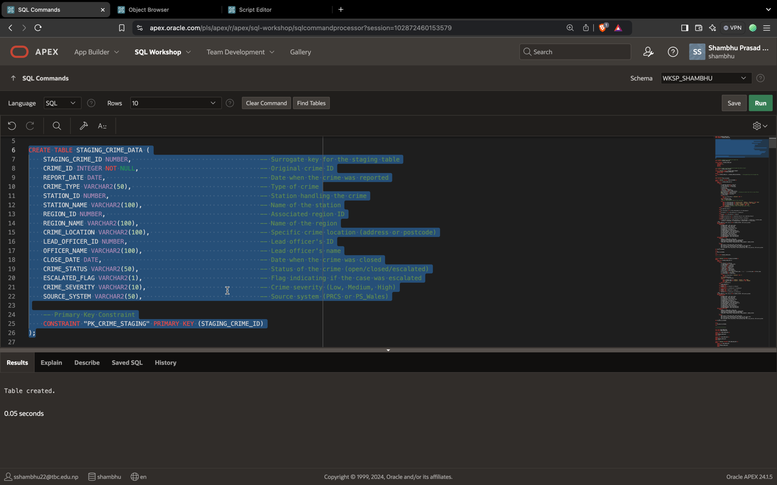

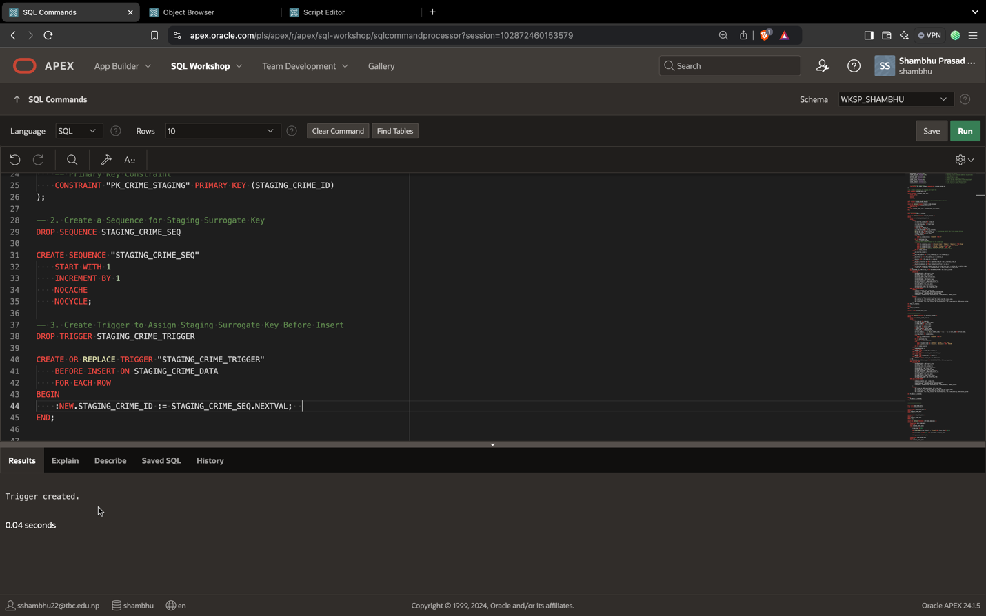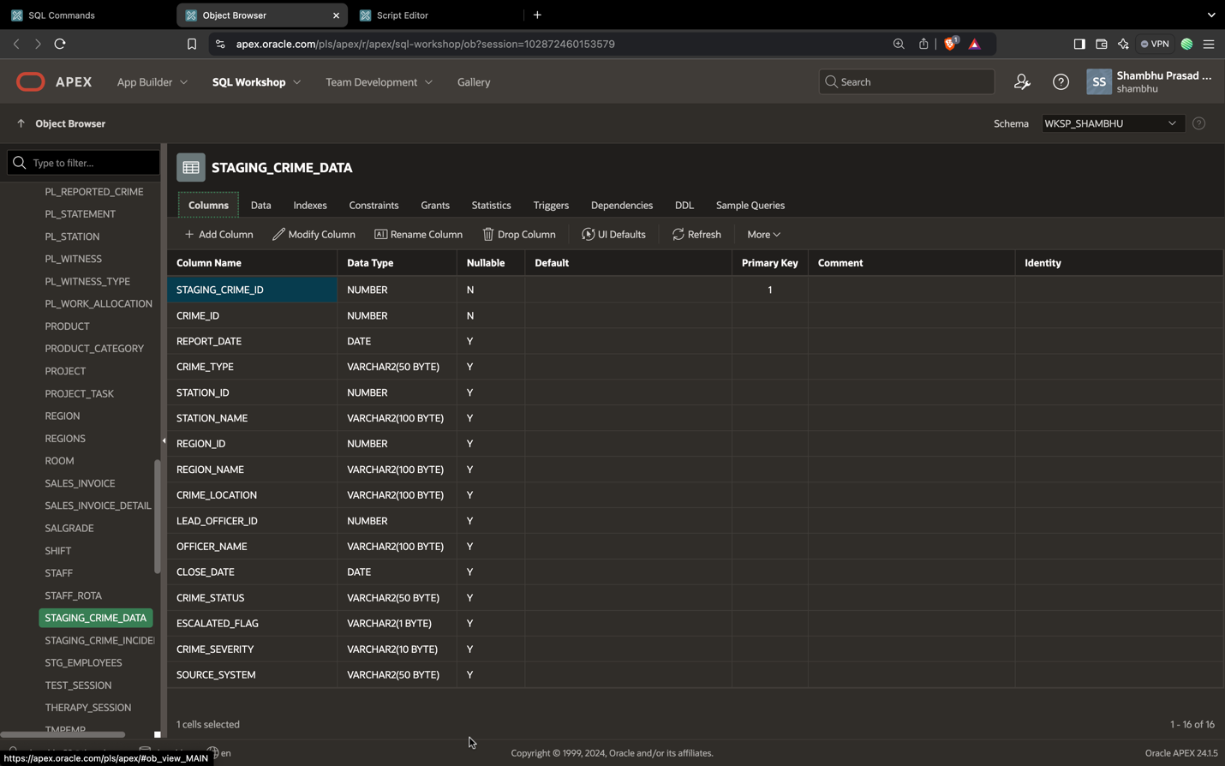

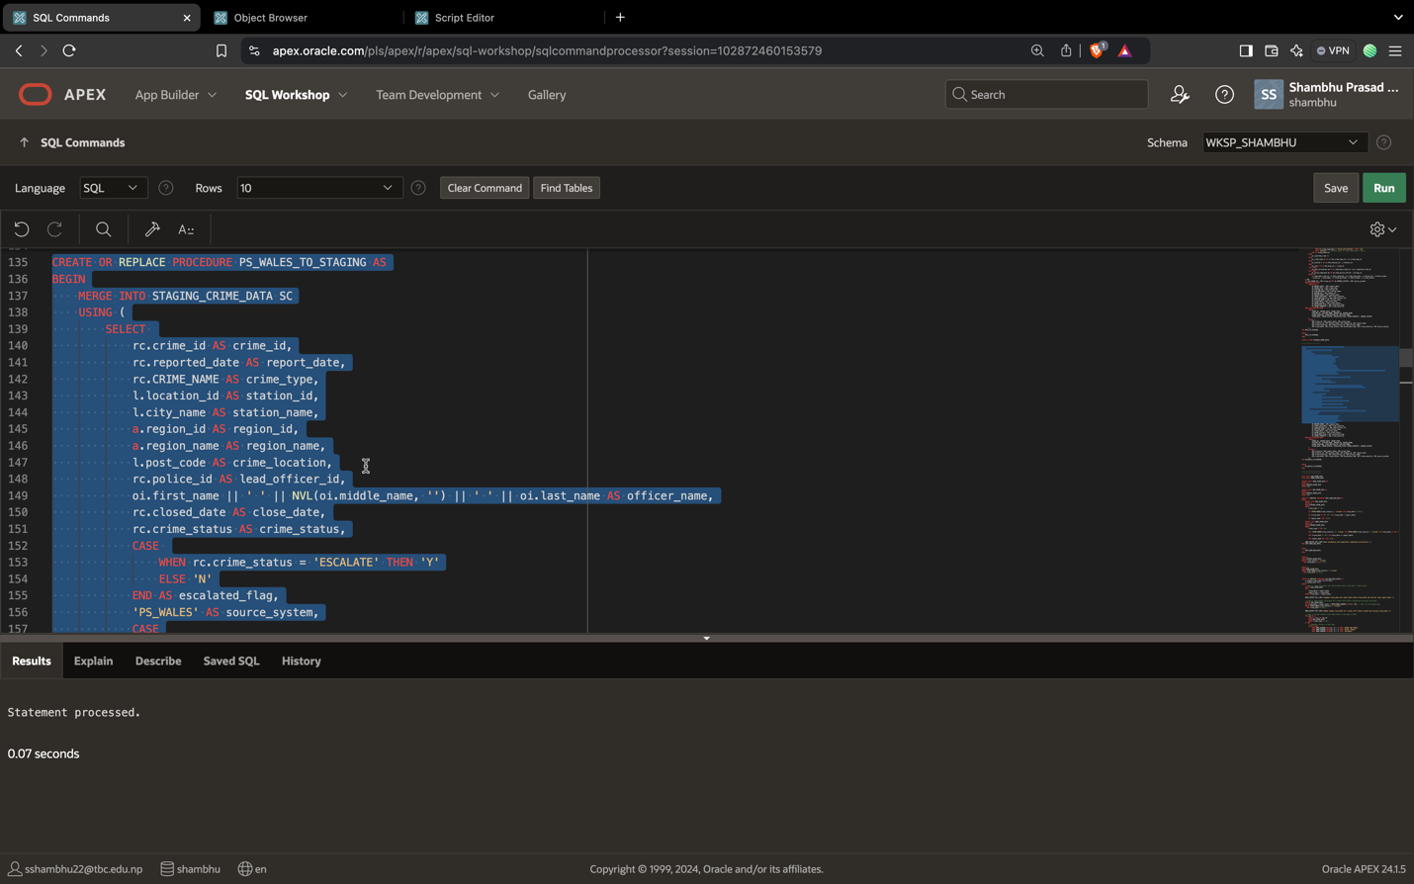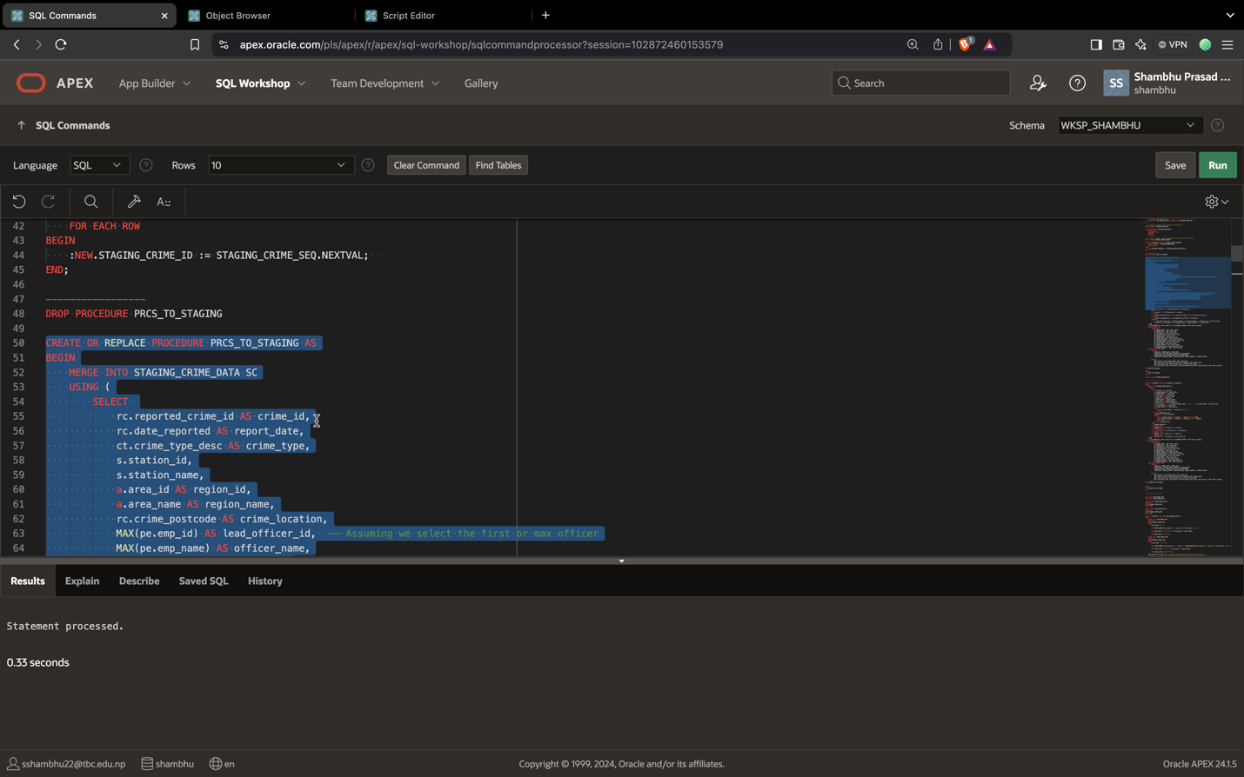

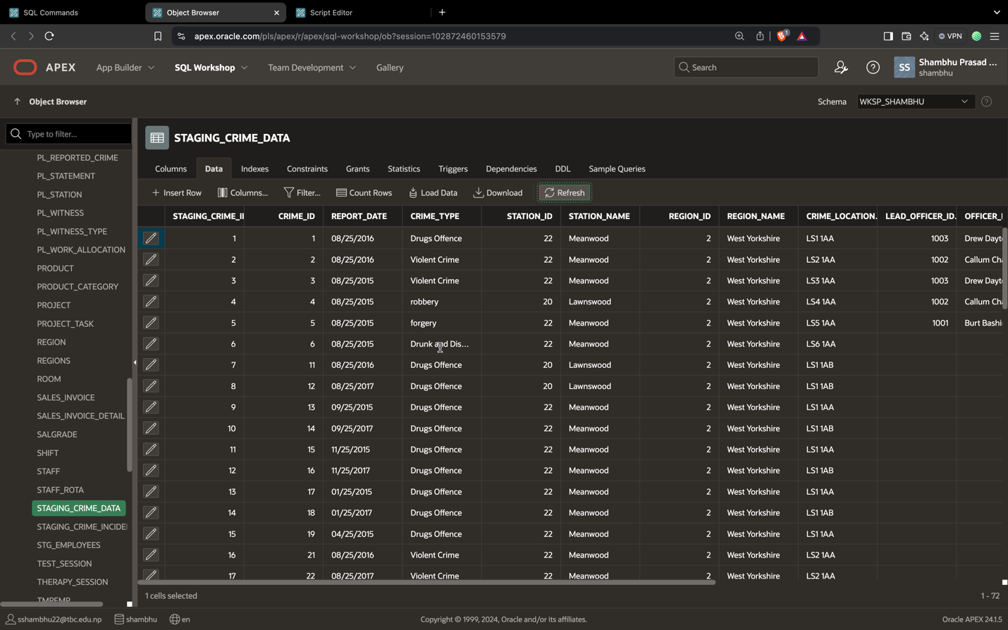

Data is loaded from the source system.

**Transformation**

In the staging area, the raw data undergoes data processing. Here, the data is transformed and consolidated for its intended analytical use case. This phase of the transformation process can include:

* Filtering, cleansing, aggregating, de-duplicating, validating and authenticating the data.
* Performing calculations, translations or summarizations based on the raw data. This can include changing row and column headers for consistency, converting currencies or other units of measurement, editing text strings and more.
* Conducting audits to ensure data quality and compliance, and computing metrics.
* Removing, encrypting or protecting data governed by industry or governmental regulators.
* Formatting the data into tables or joined tables to match the schema of the target data warehouse.

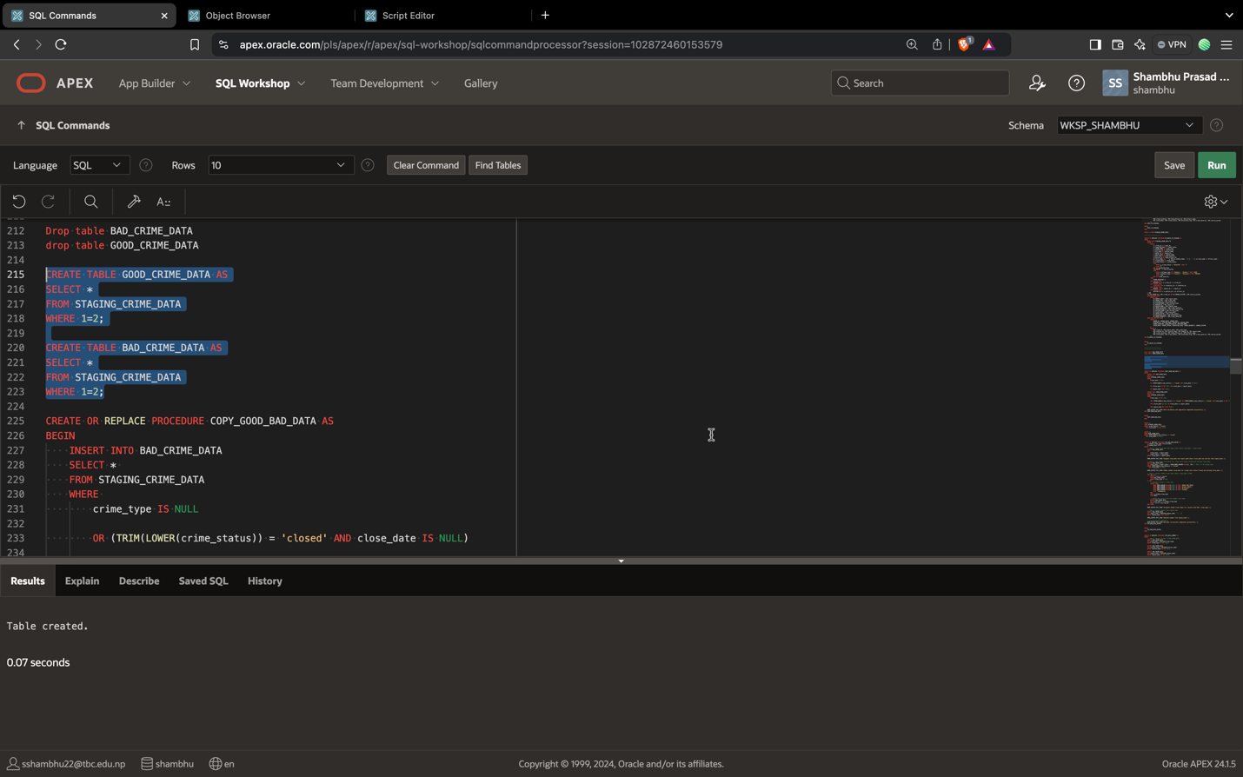

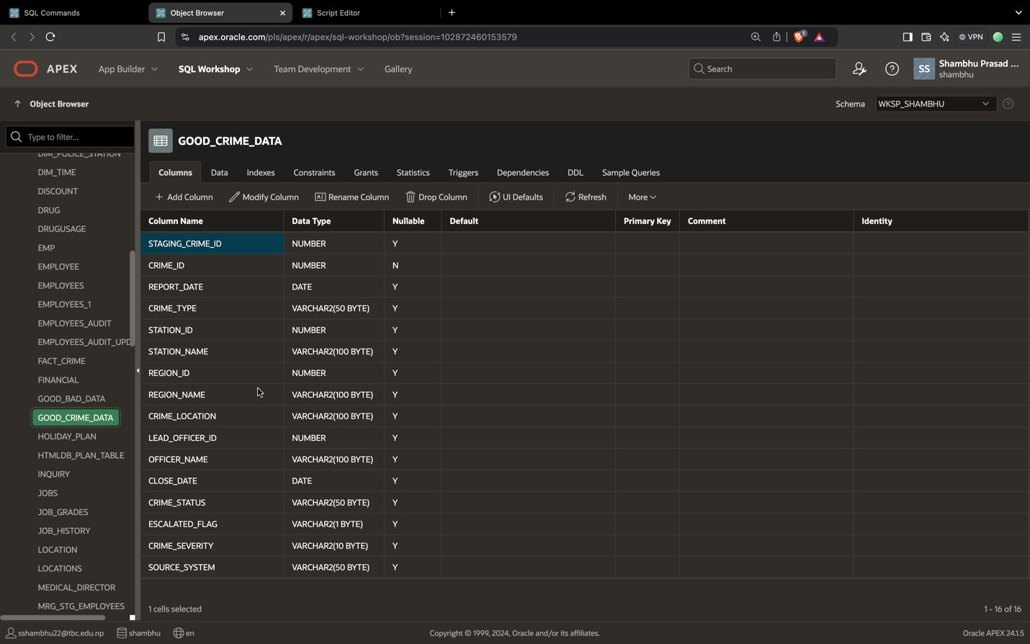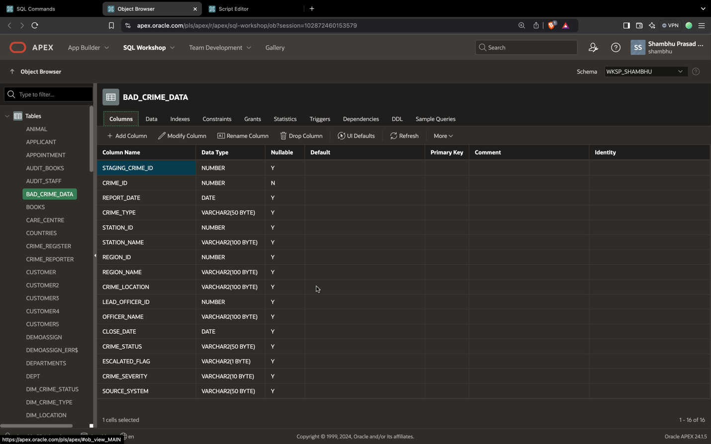

Good and Bad table is created to separate the good data and bad data.

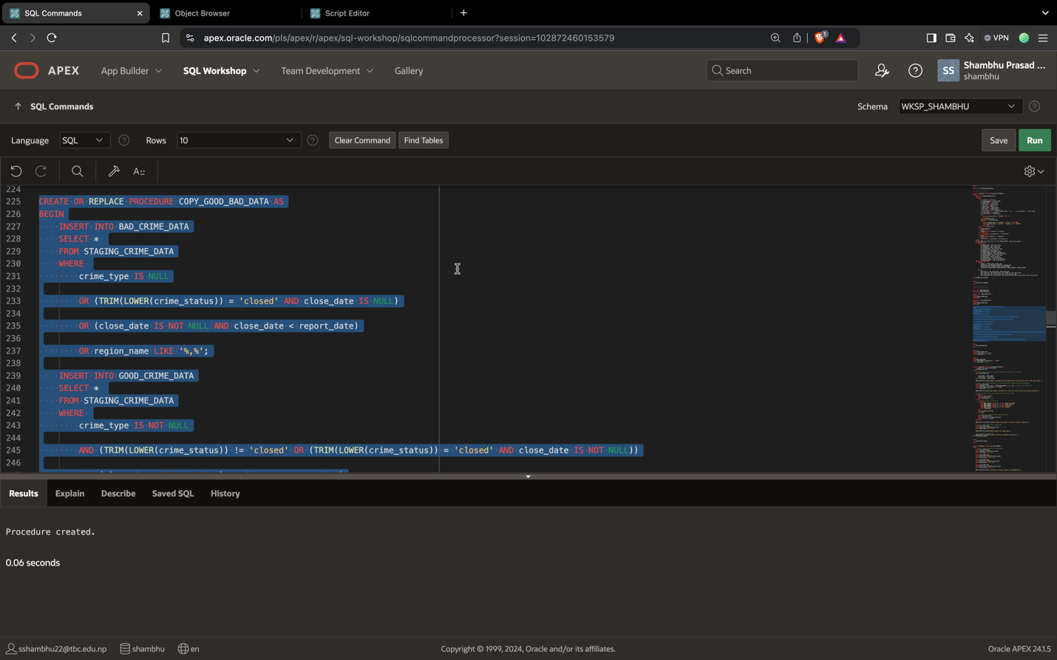

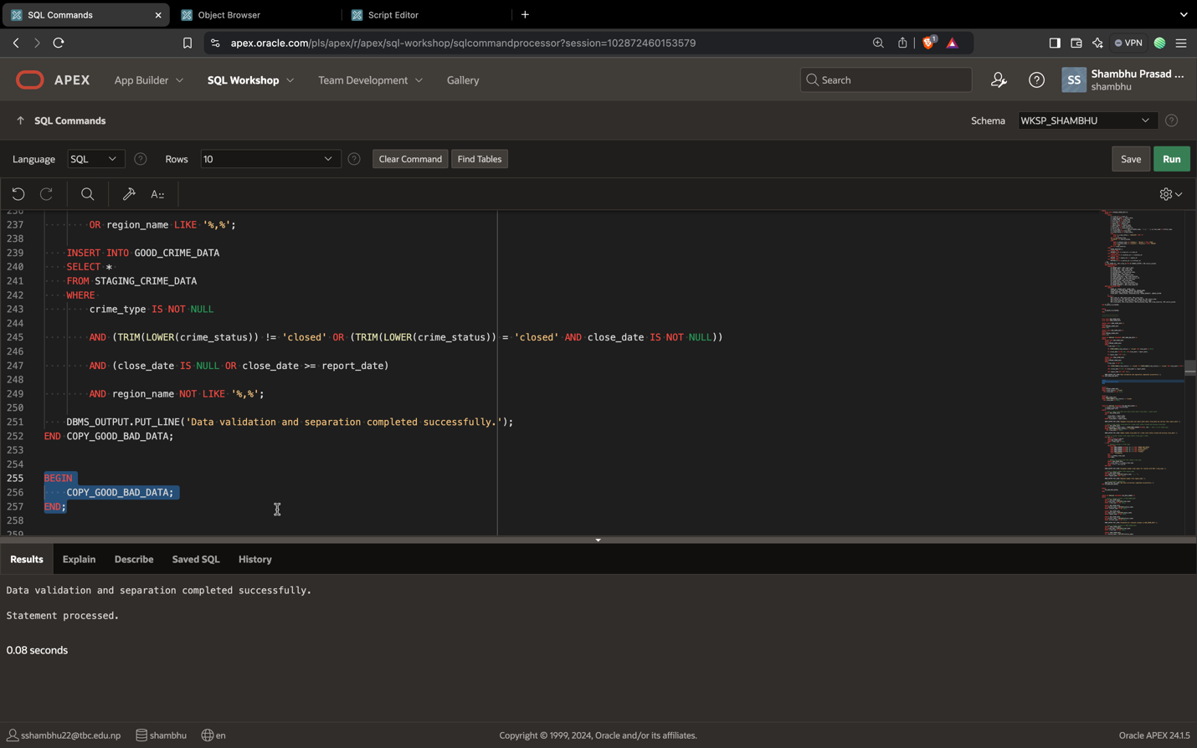

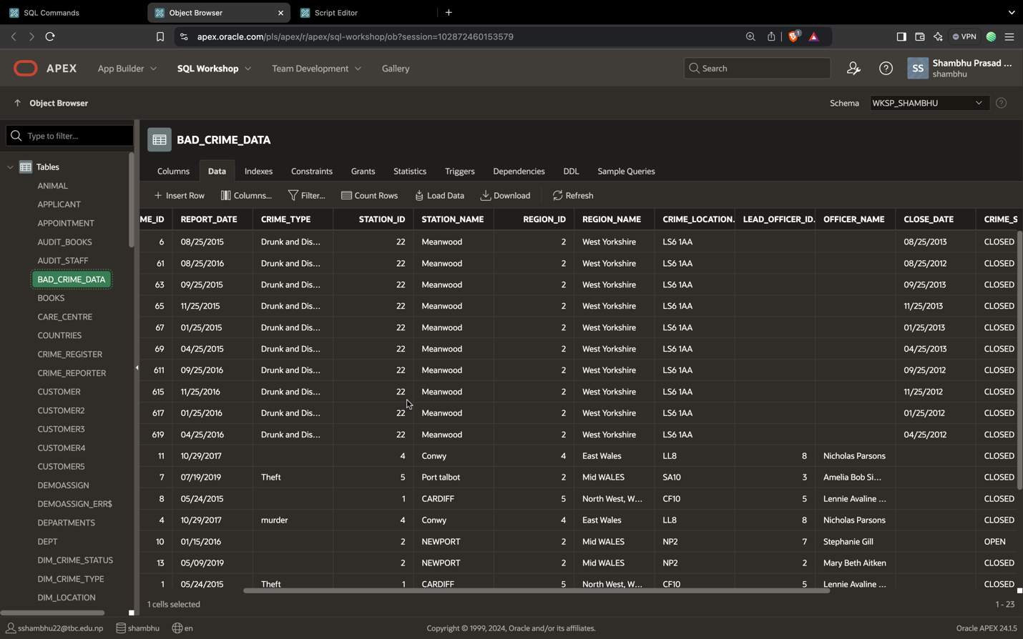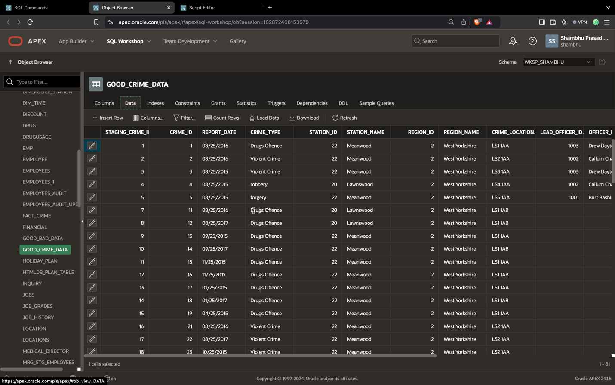

Data is separated on the basis of if data is null, incorrect date, date missing of closed crime.

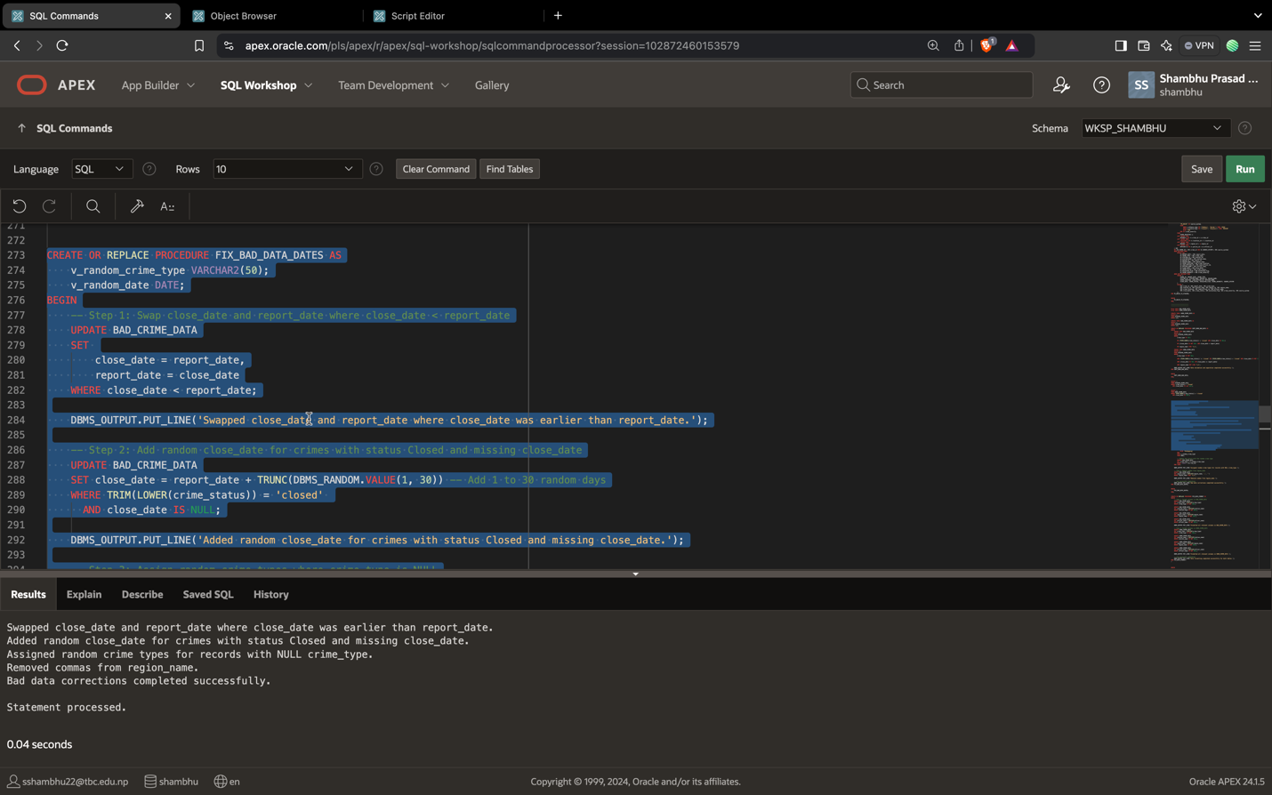

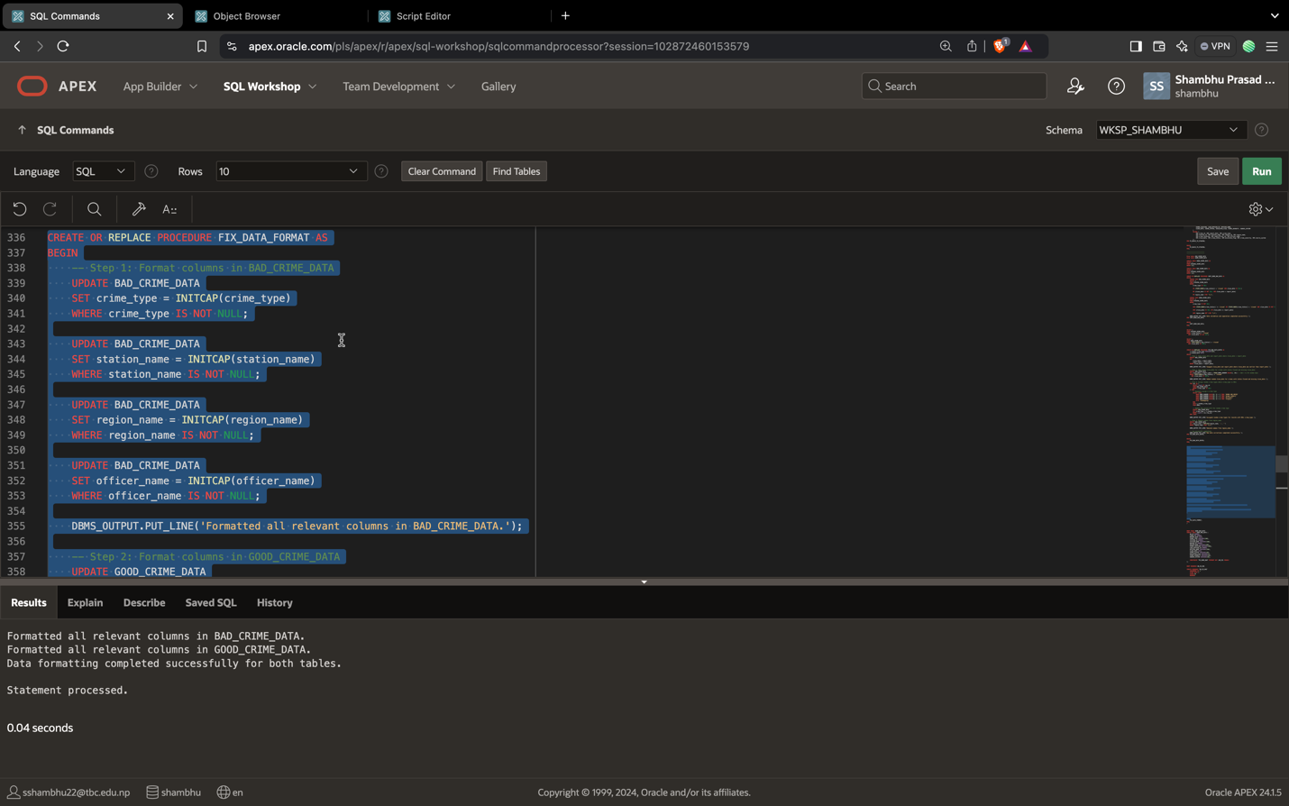

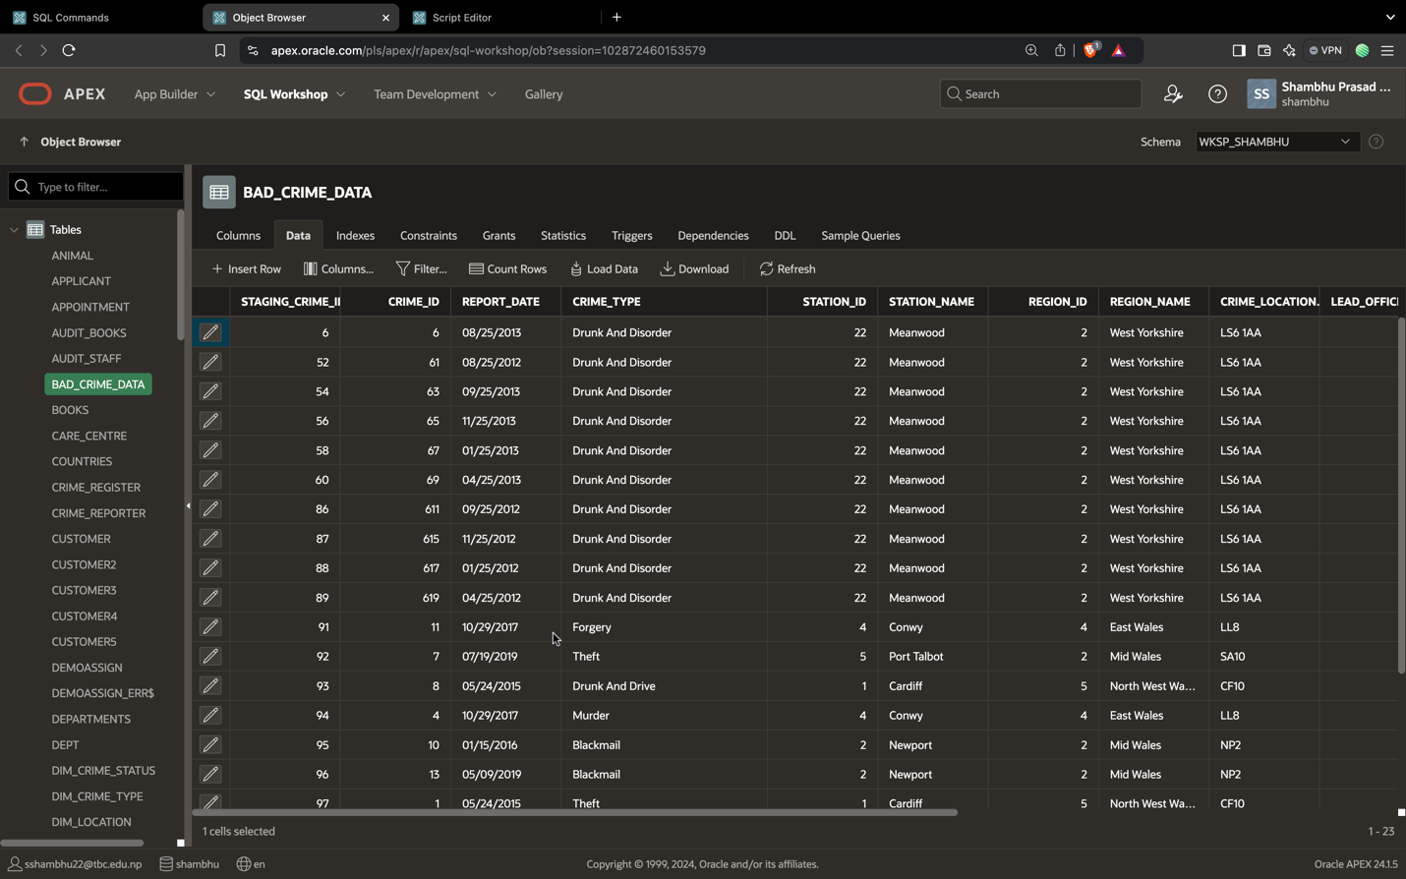

Letter case us updated of all the data such as first letter of word is capital and other should be small.

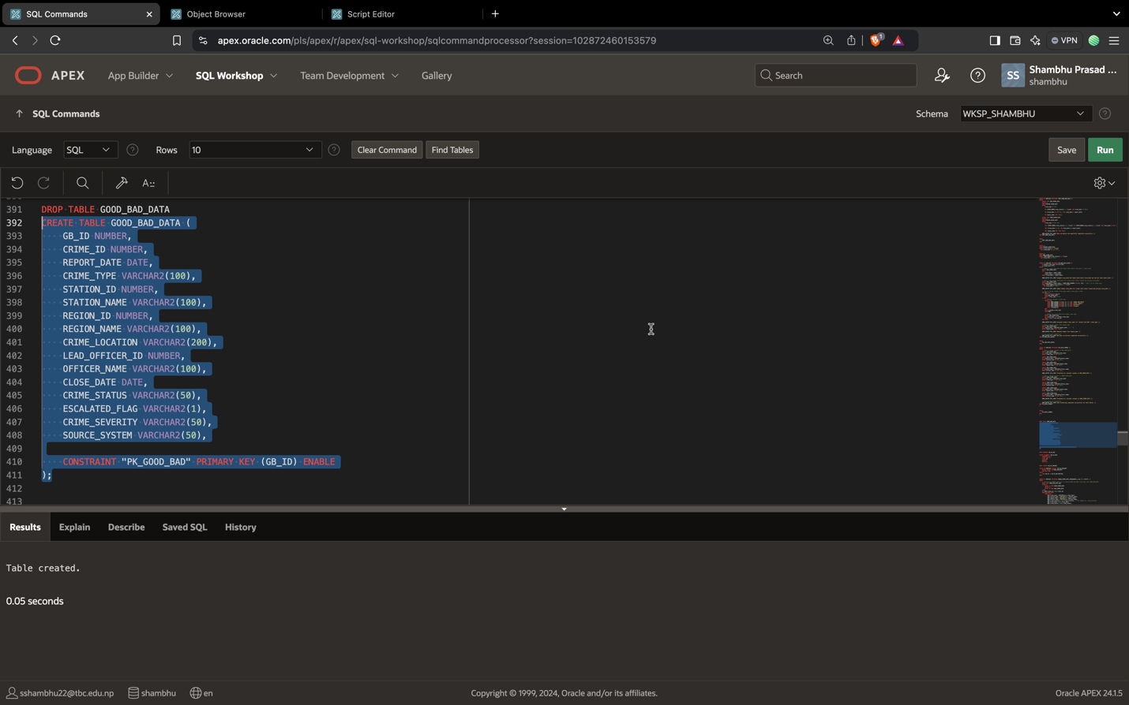

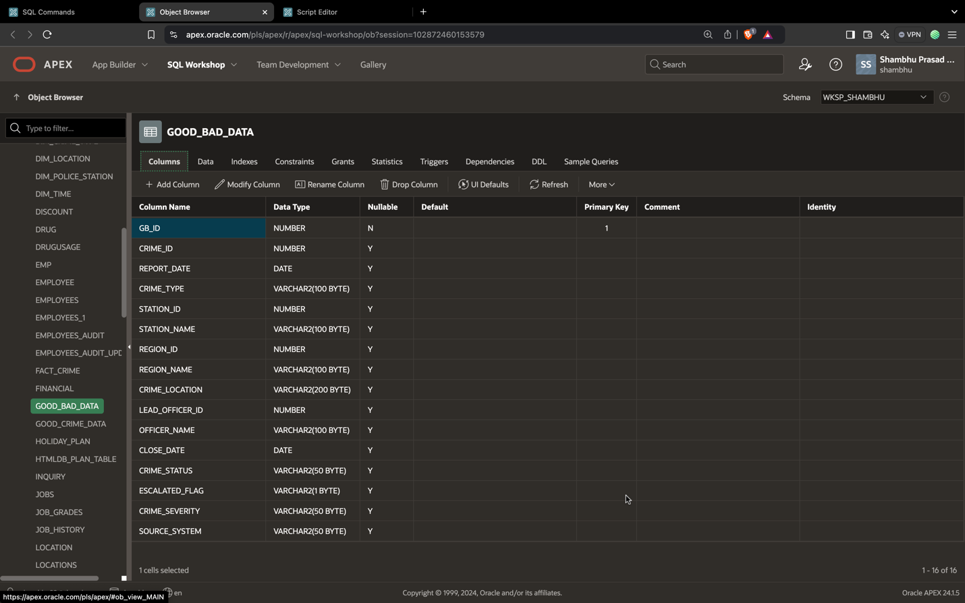

Then good_bad_data table is created to put all the cleaned data in one table.

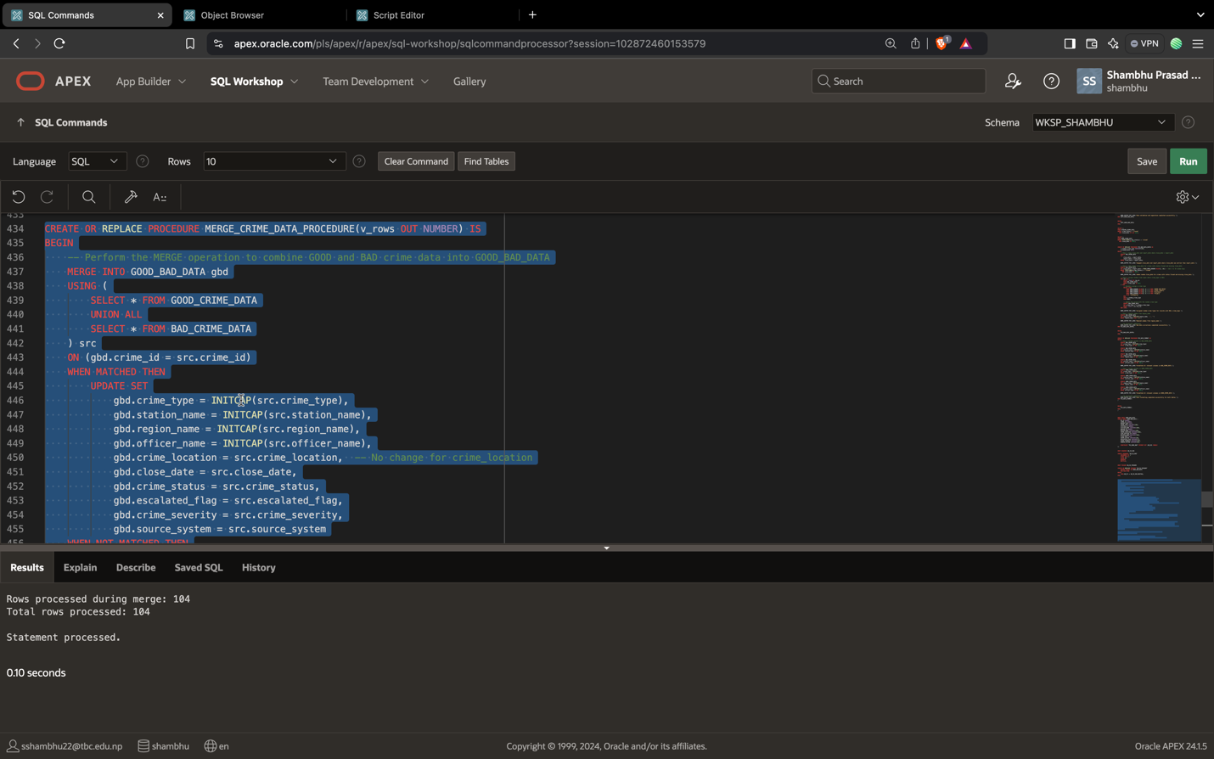

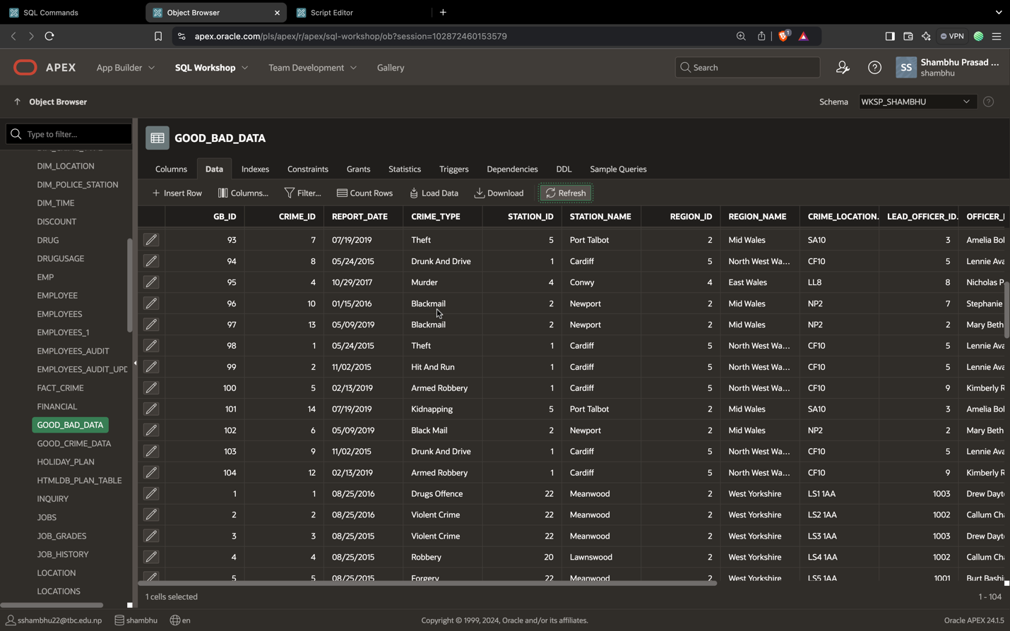

Data being inserted in the good_bad_data after the cleaning all the data.

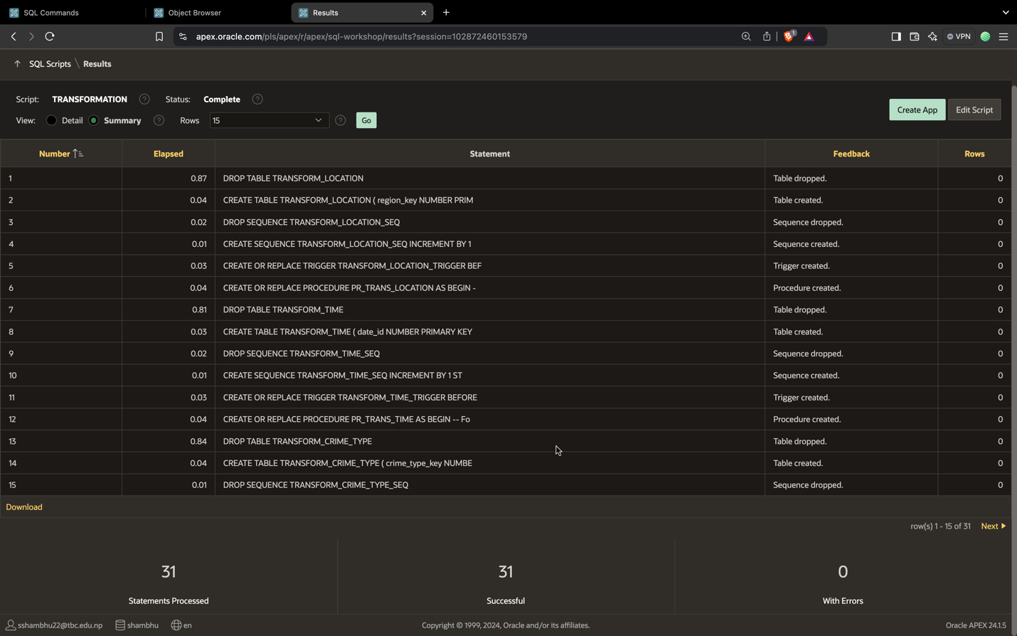

Transformation table is created and data is inserted in it data according to the star schema.

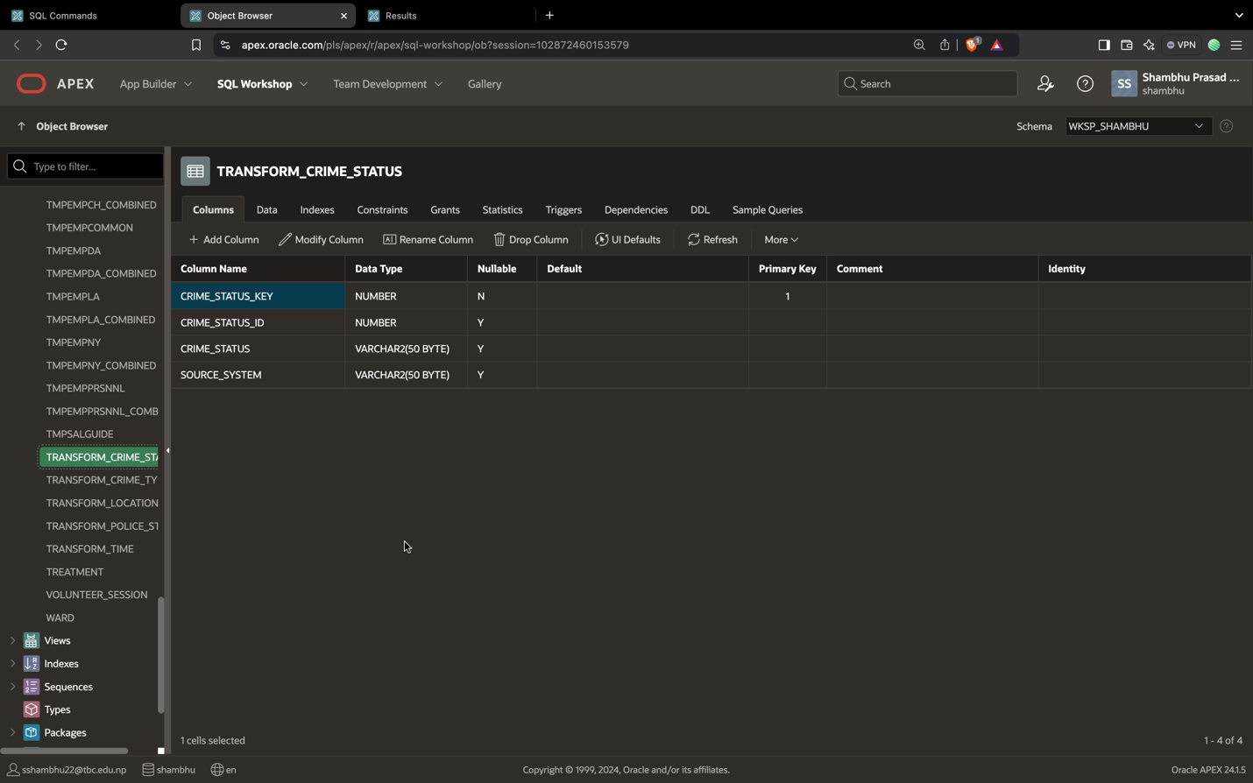

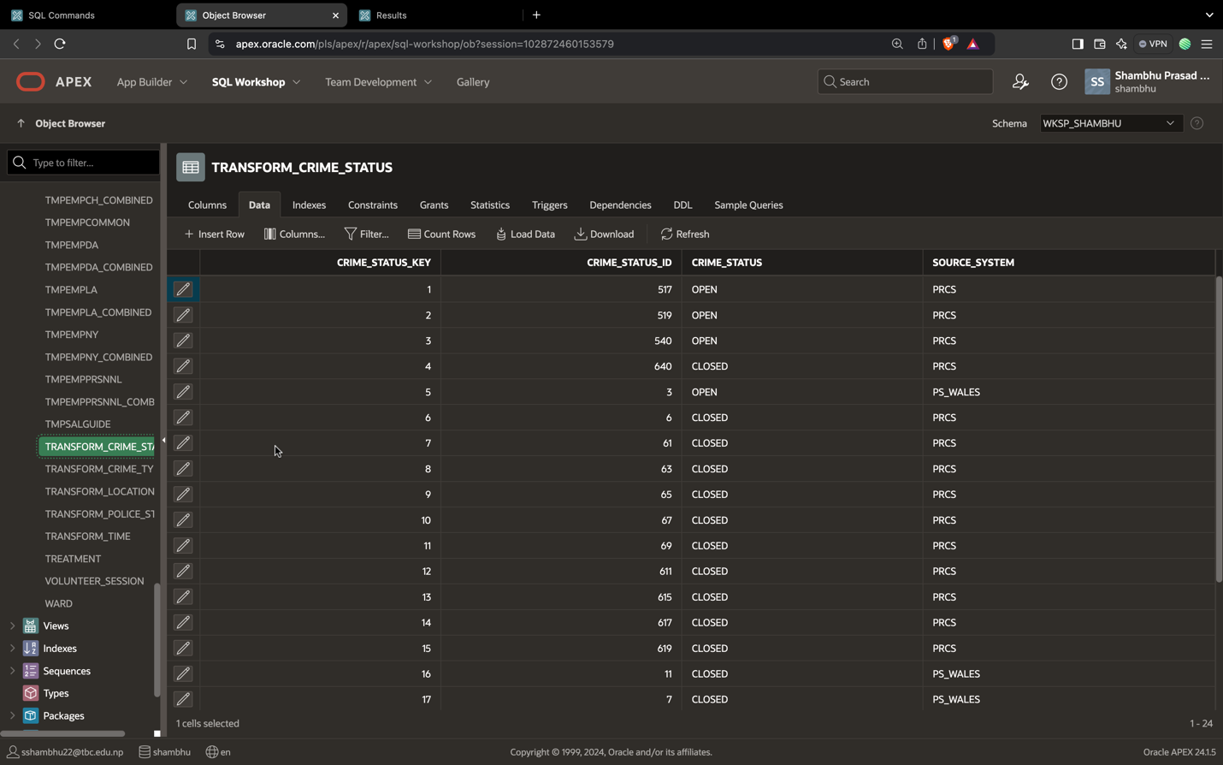

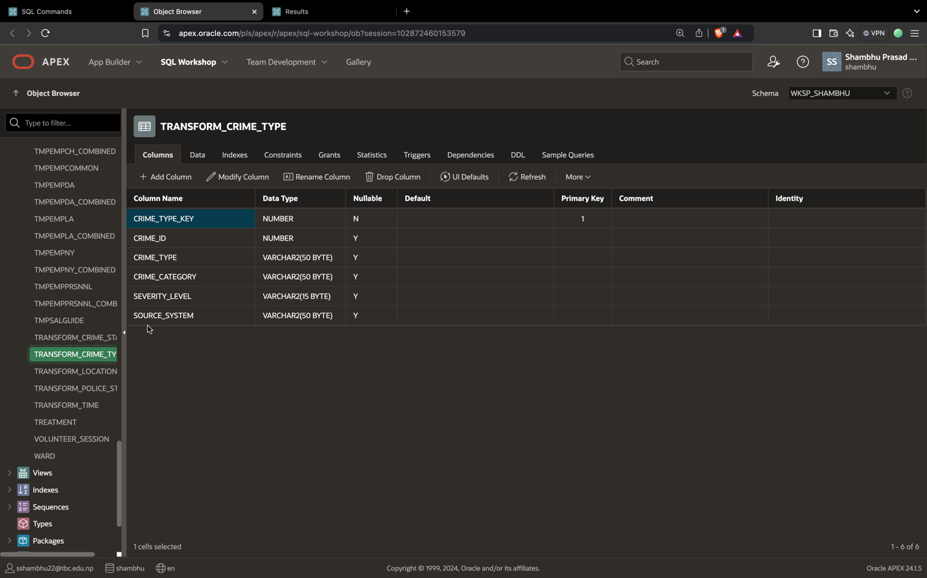

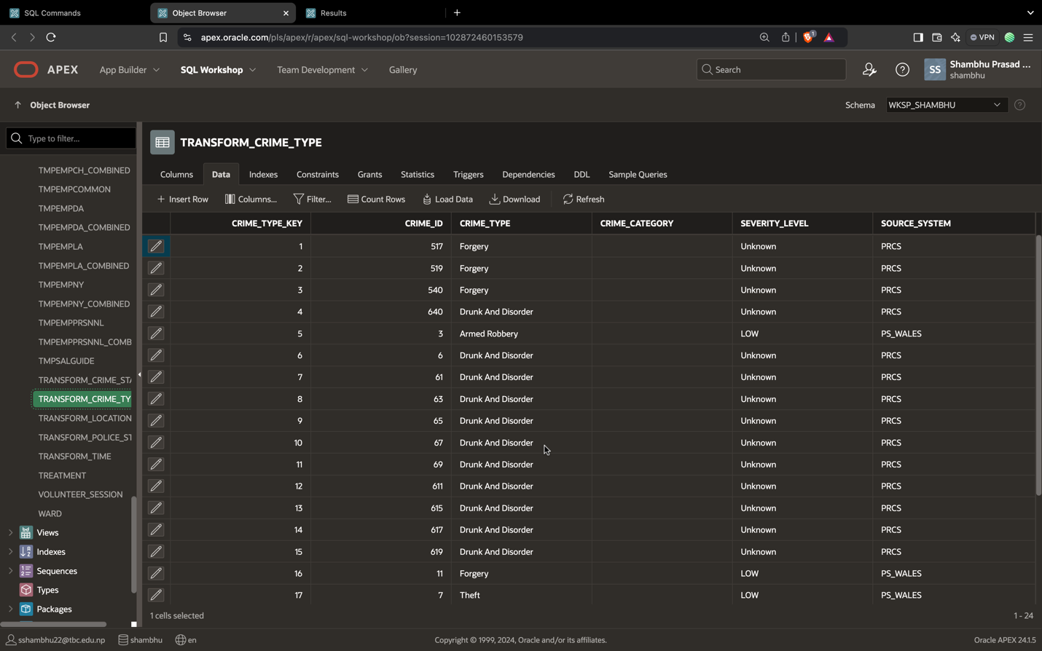

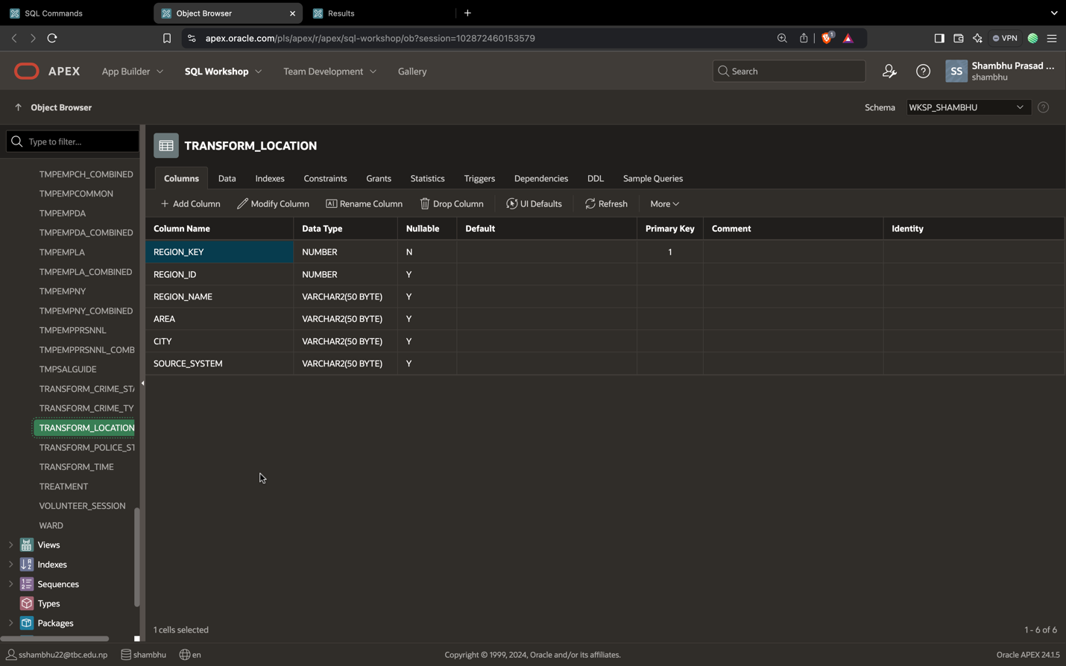

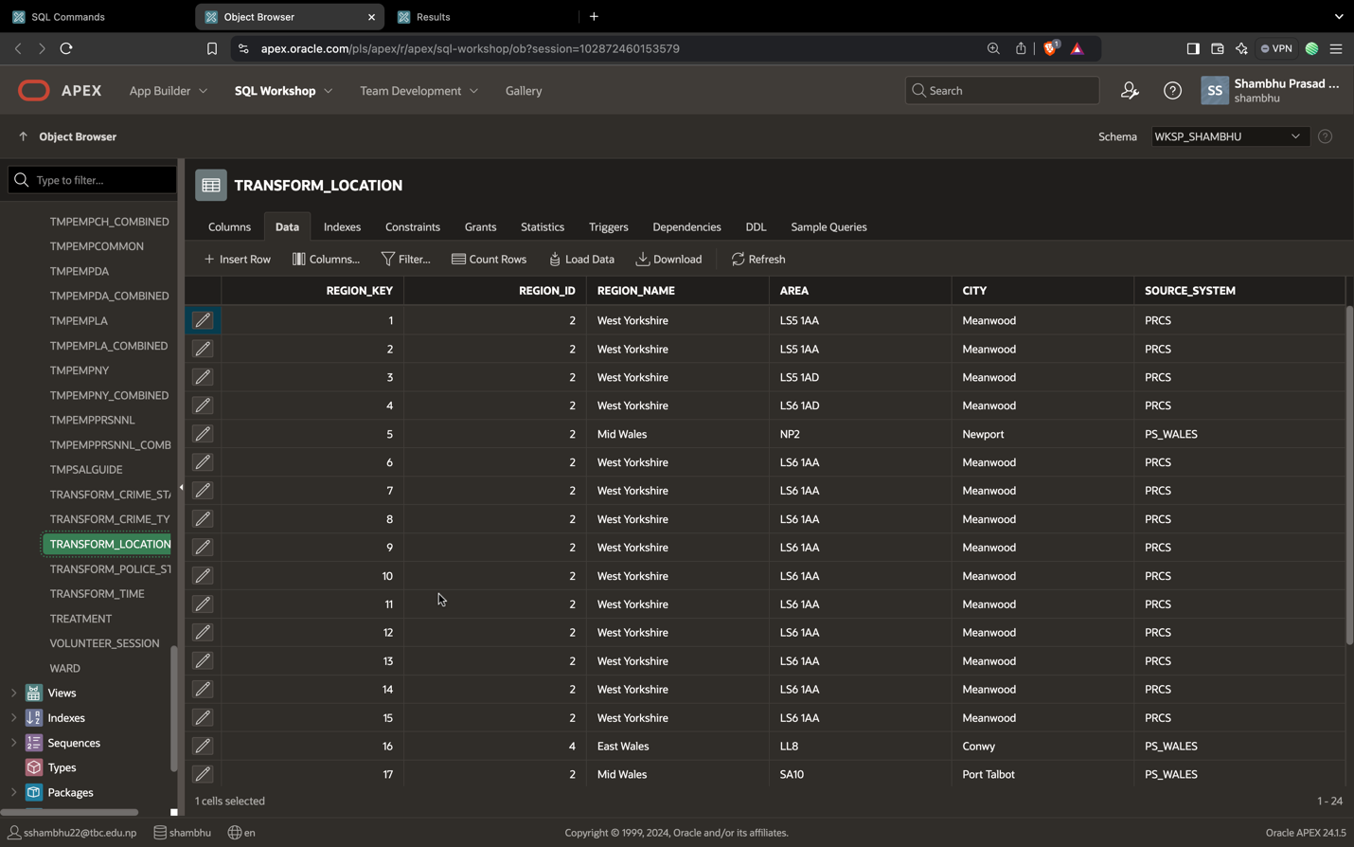

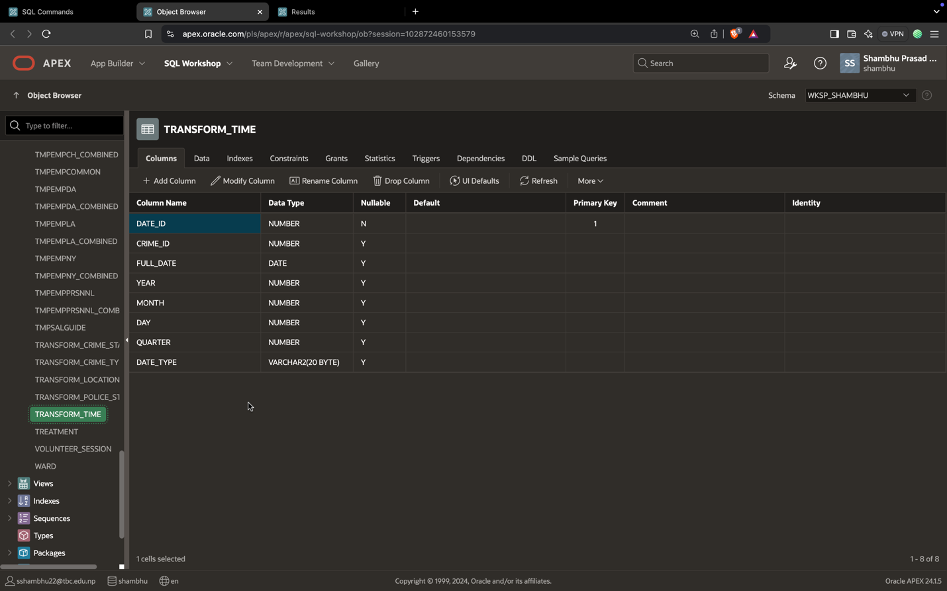

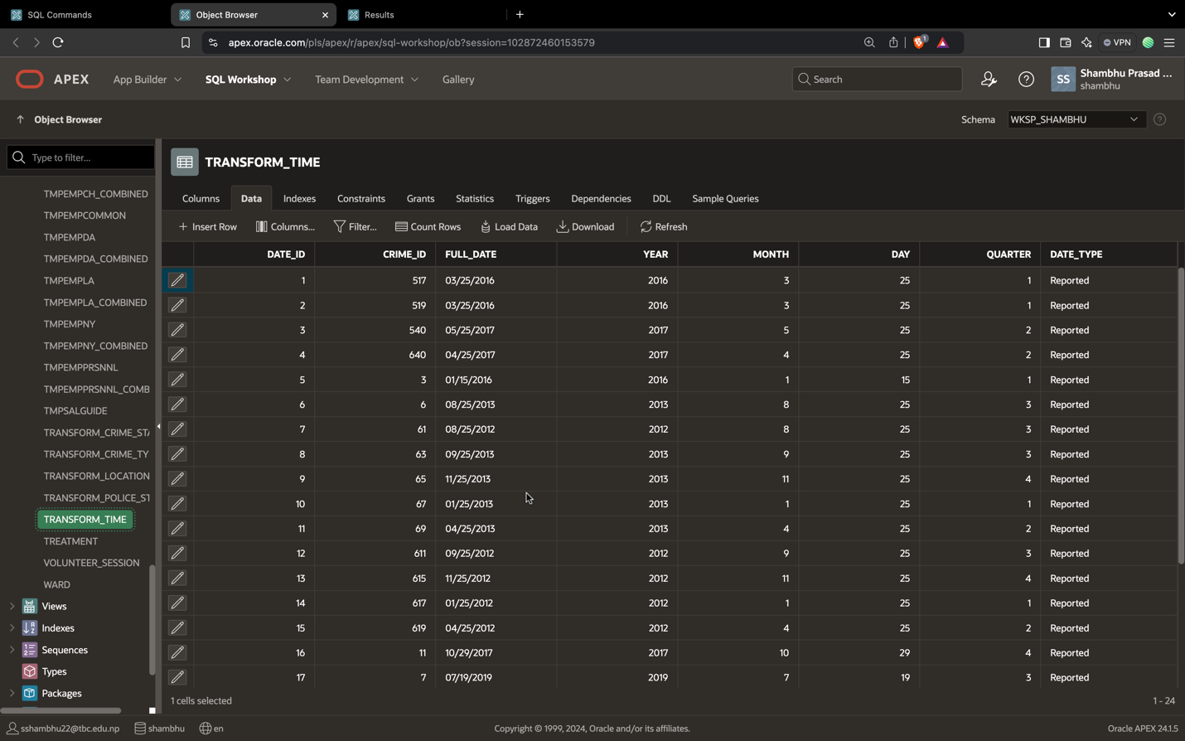

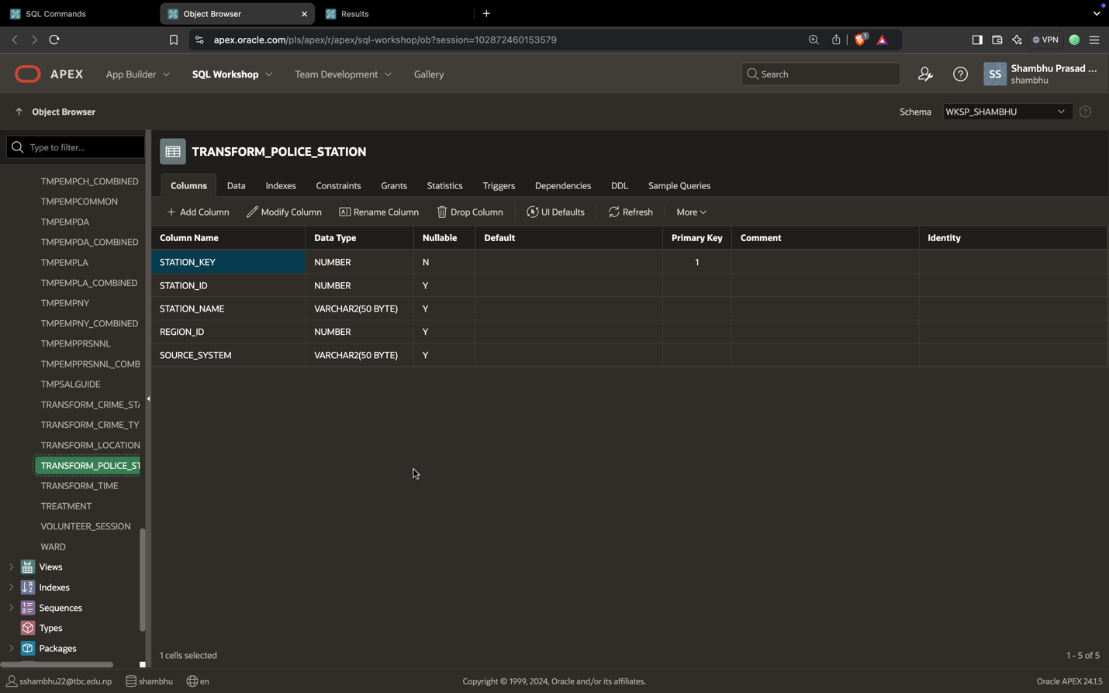

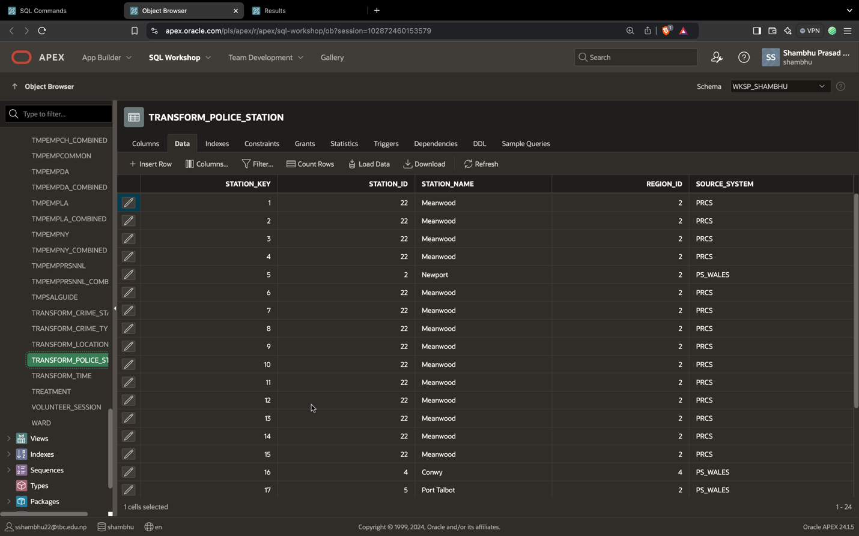

## **Load**

In this last step, the transformed data is moved from the staging area into a target data warehouse. Typically, this involves an initial loading of all data, followed by periodic loading of incremental data changes and, less often, full refreshes to erase and replace data in the warehouse. For most organizations that use ETL, the process is automated, well-defined, continuous and batch-driven.

In this step, from the star schema script is generated and table is being created from the same script and data from the transform table is inserted in the dim table.

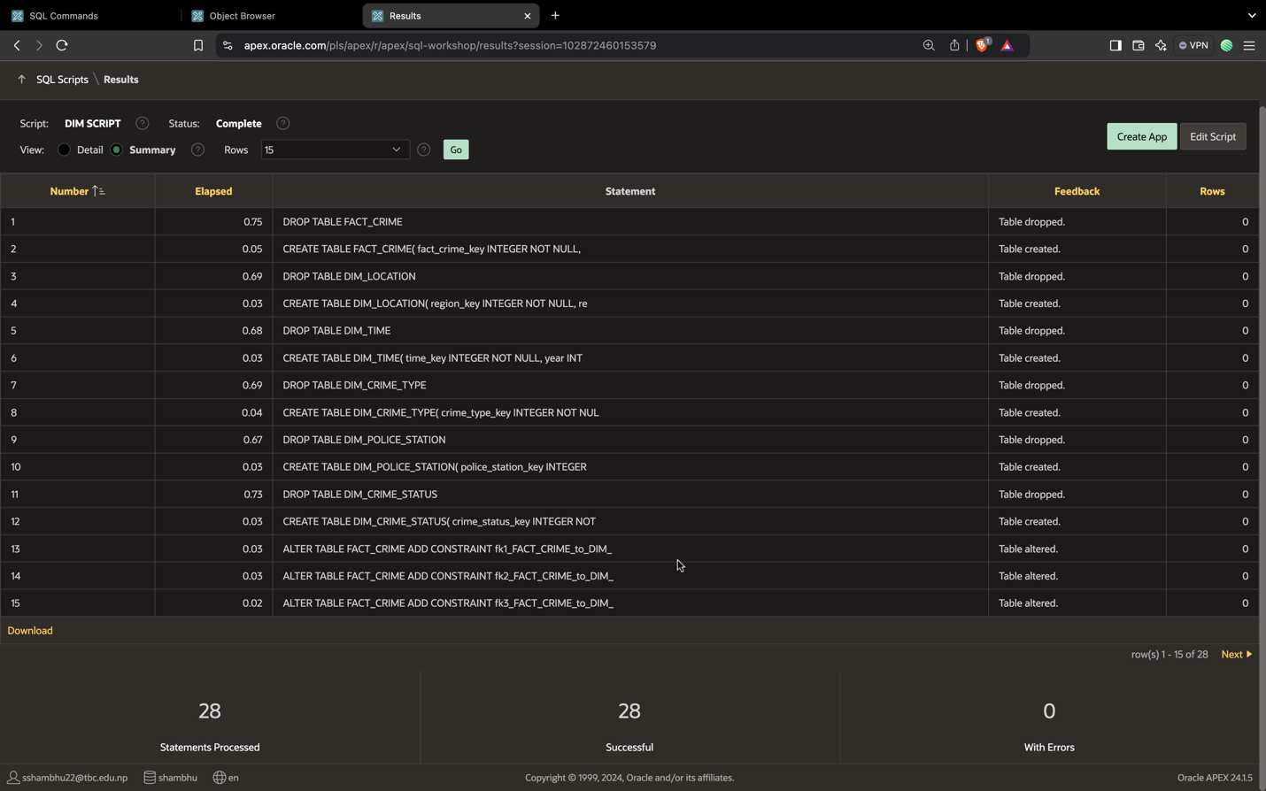

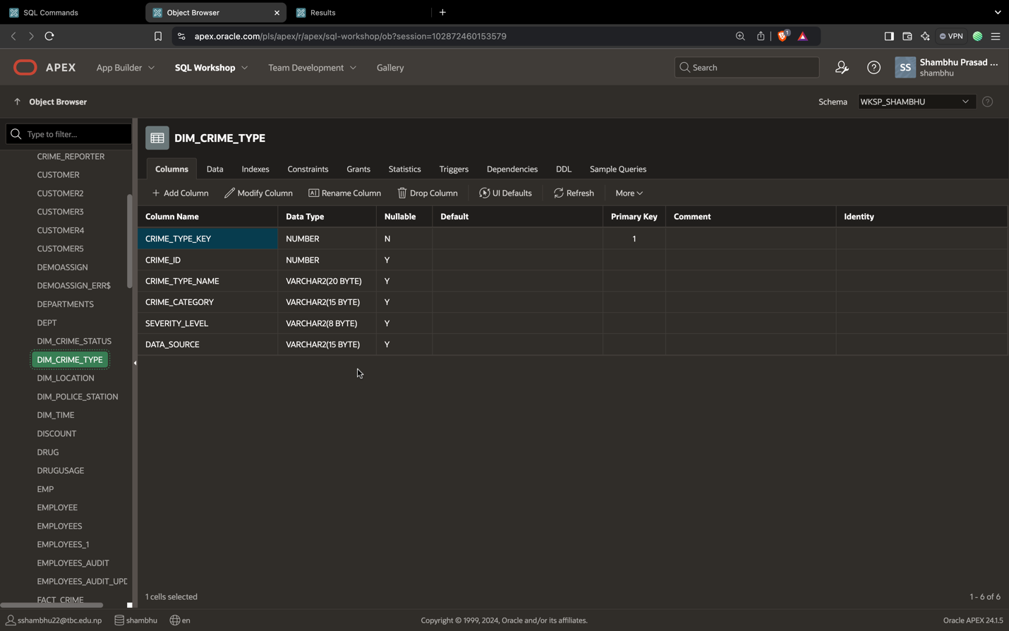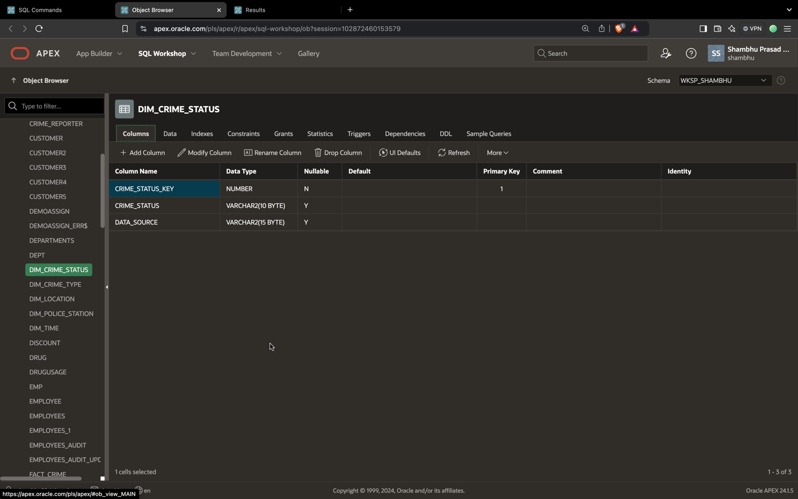

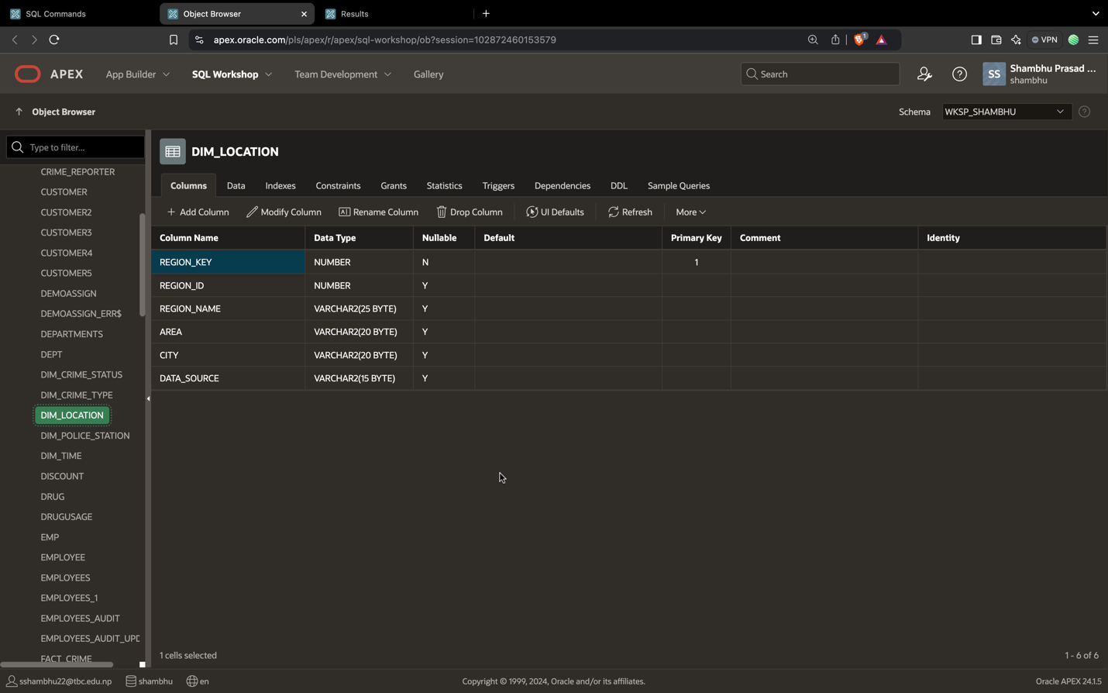

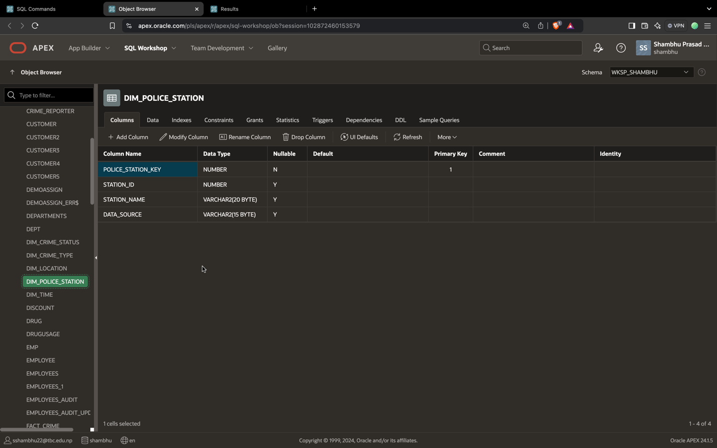

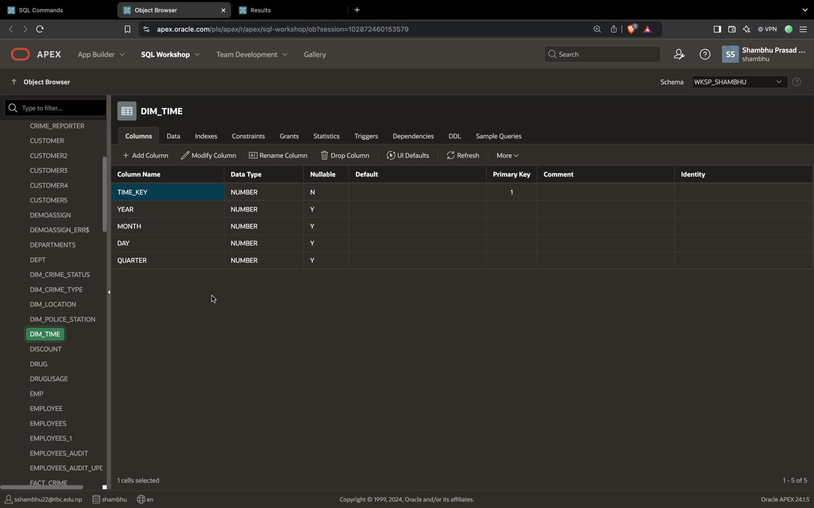

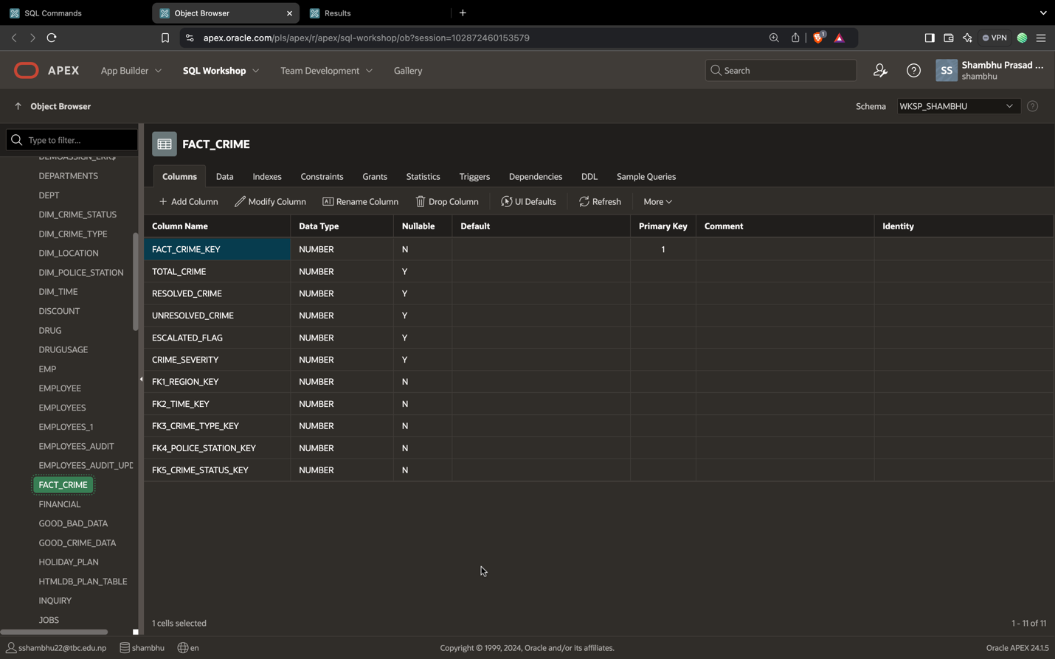

Loading data in Dim tables

In the bellow screenshot, data is being inserted from the transform table and the staging table after data is cleaned to use join keyword.

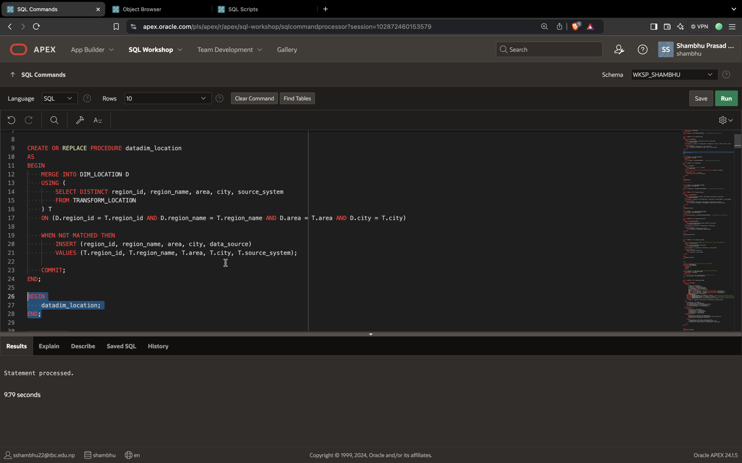

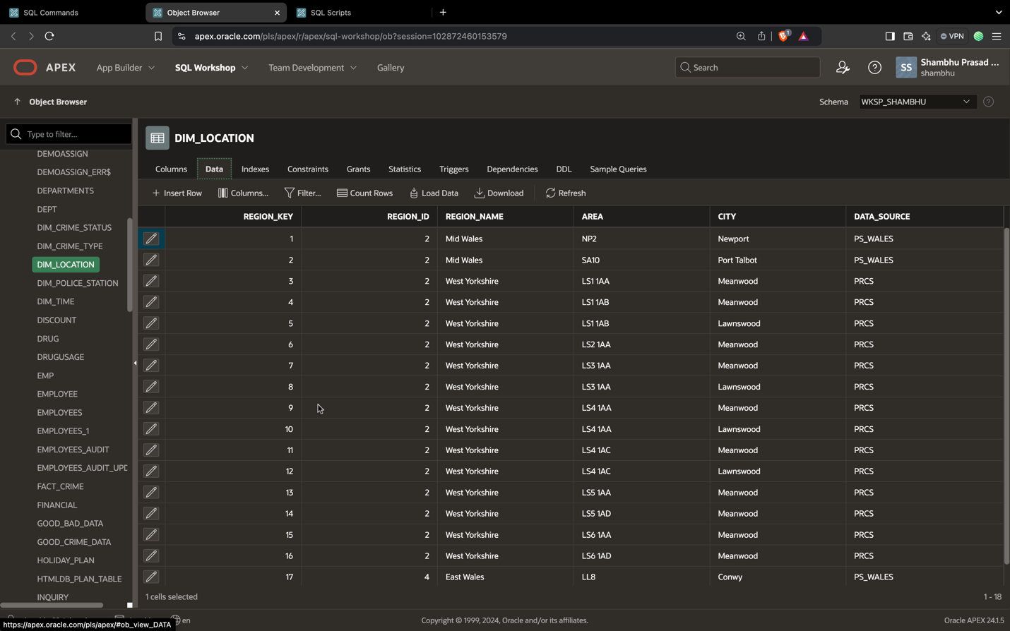

Data inserted in Dim_location.

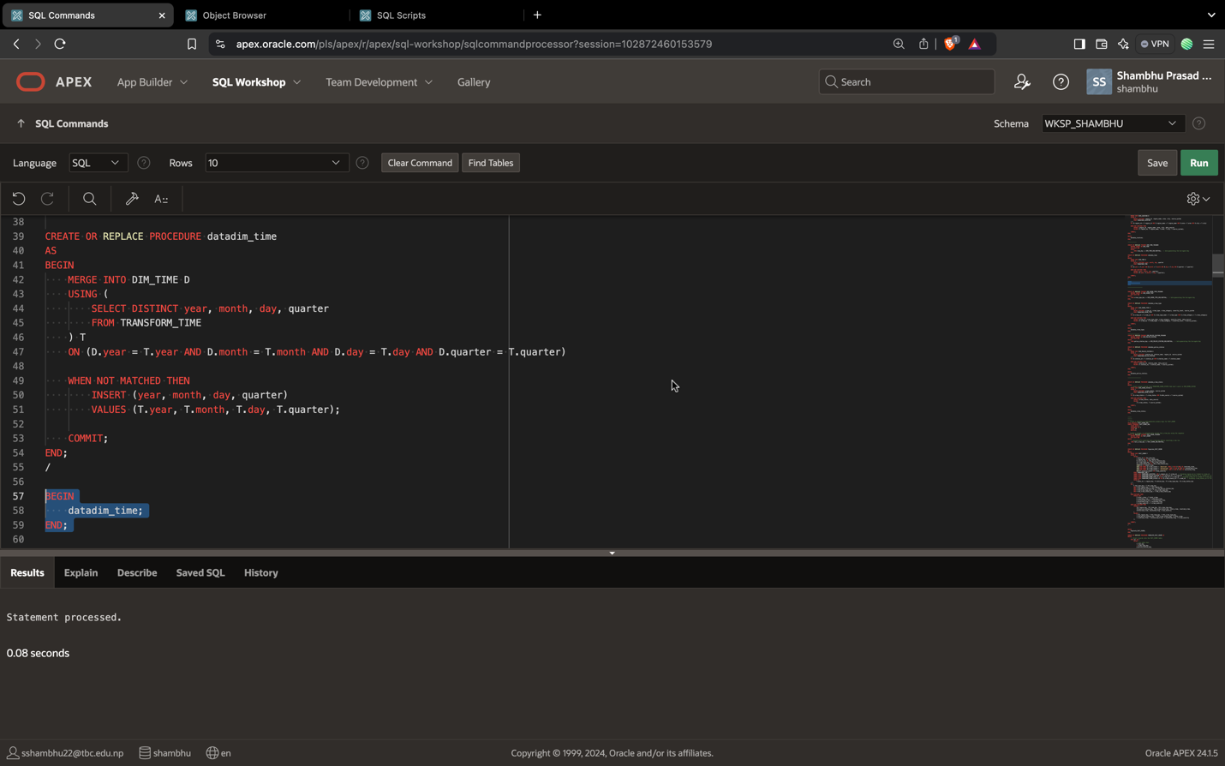

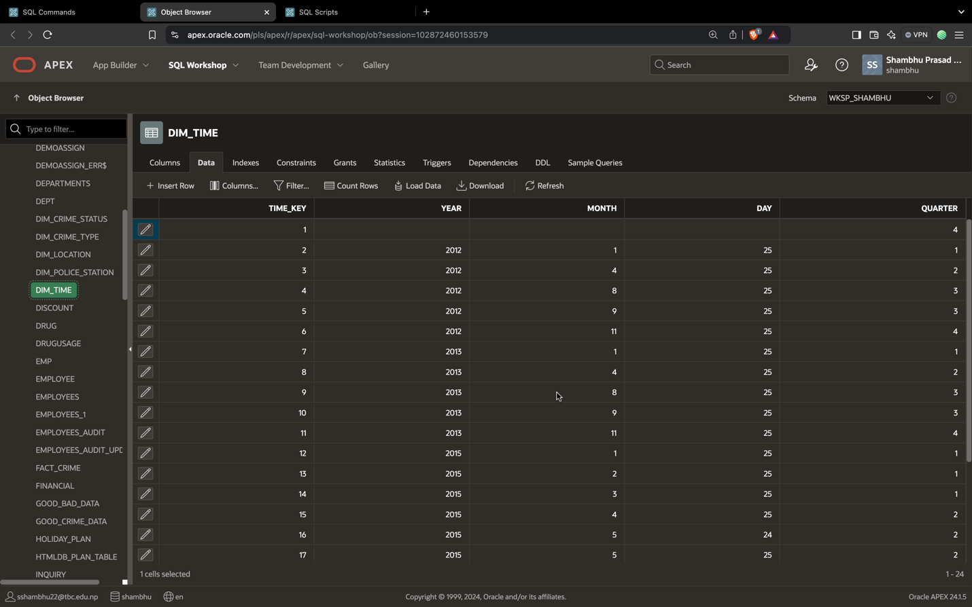

Data inserted into dim_time .

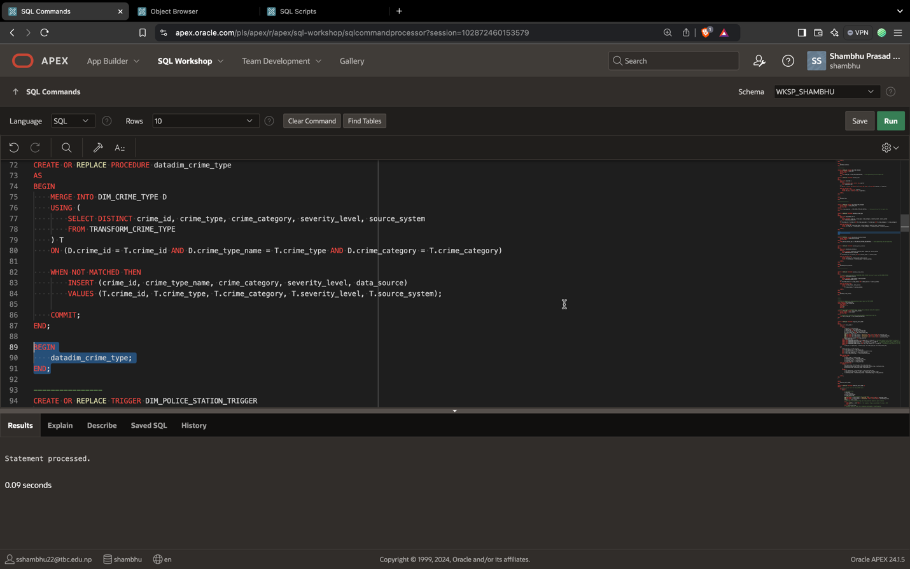

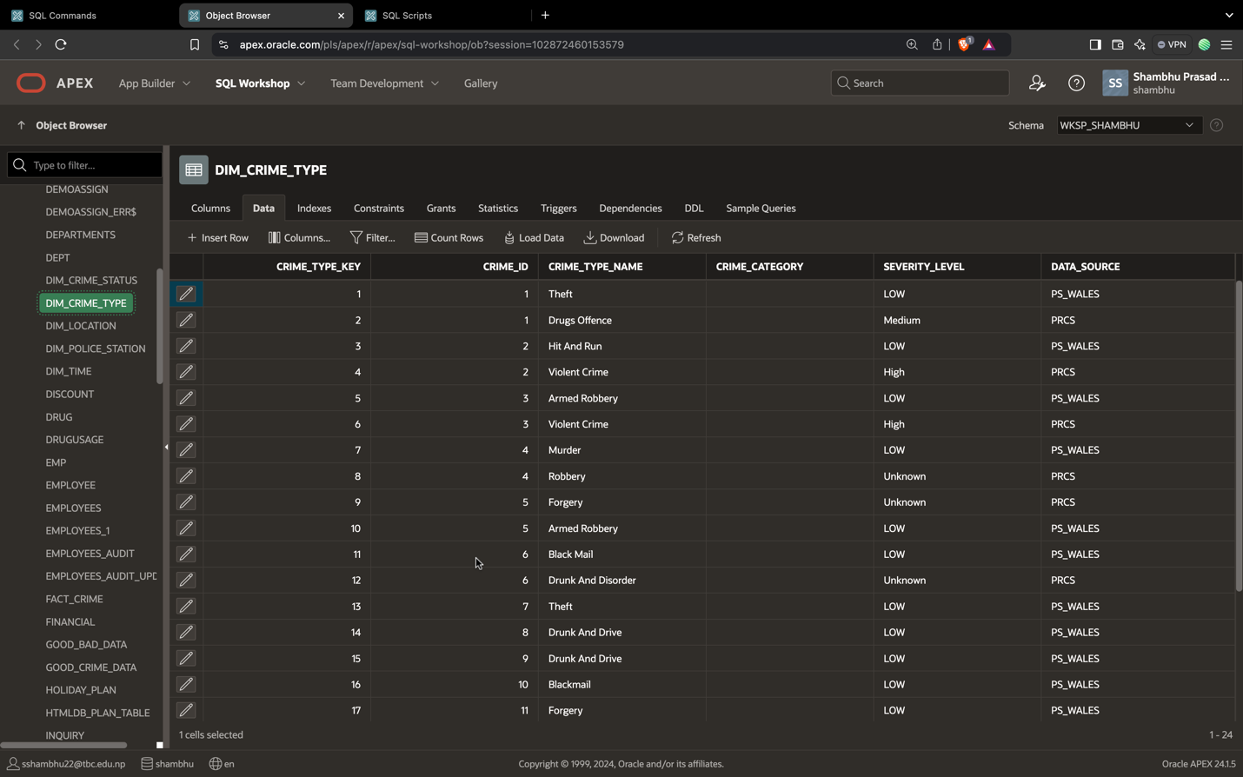

Data inserted into dim_crime_type.

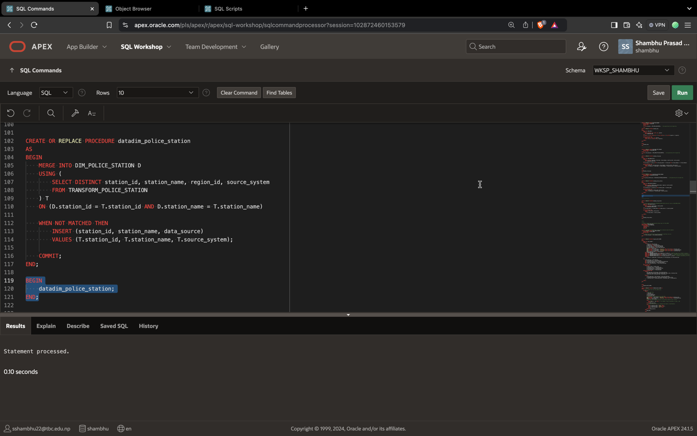

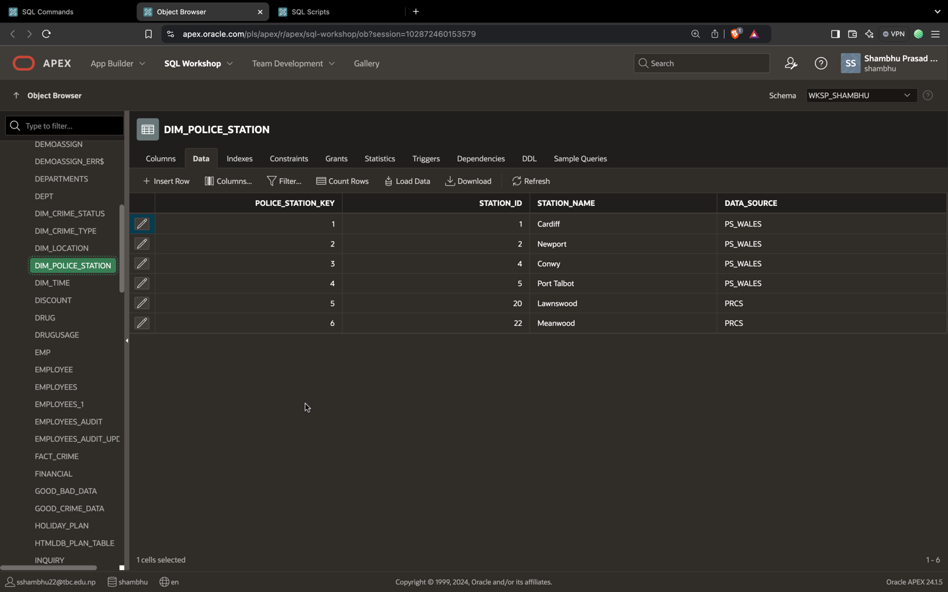

Data inserted into dim_police_station.

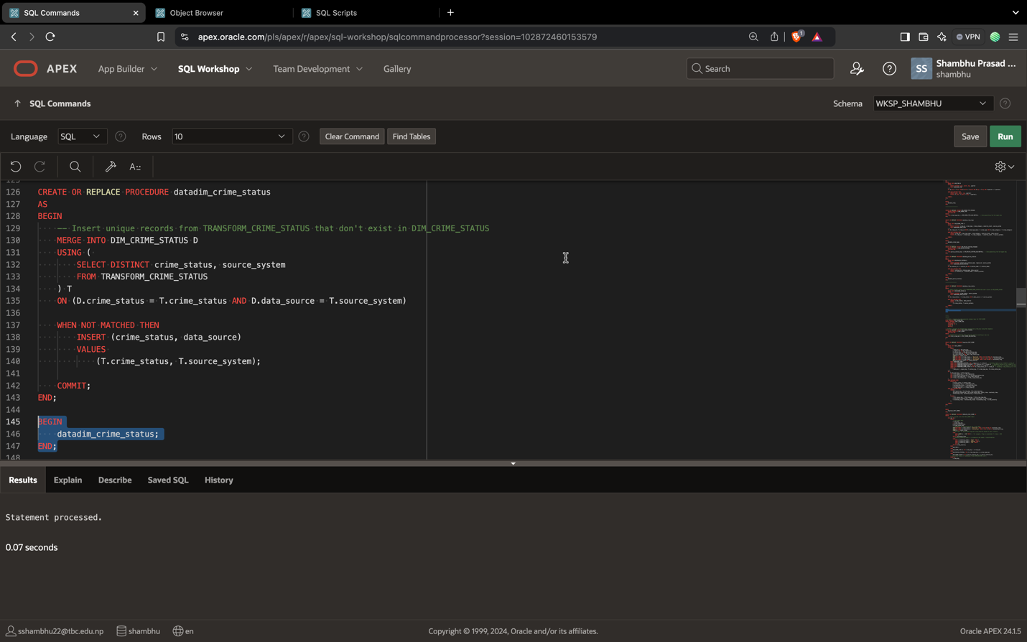

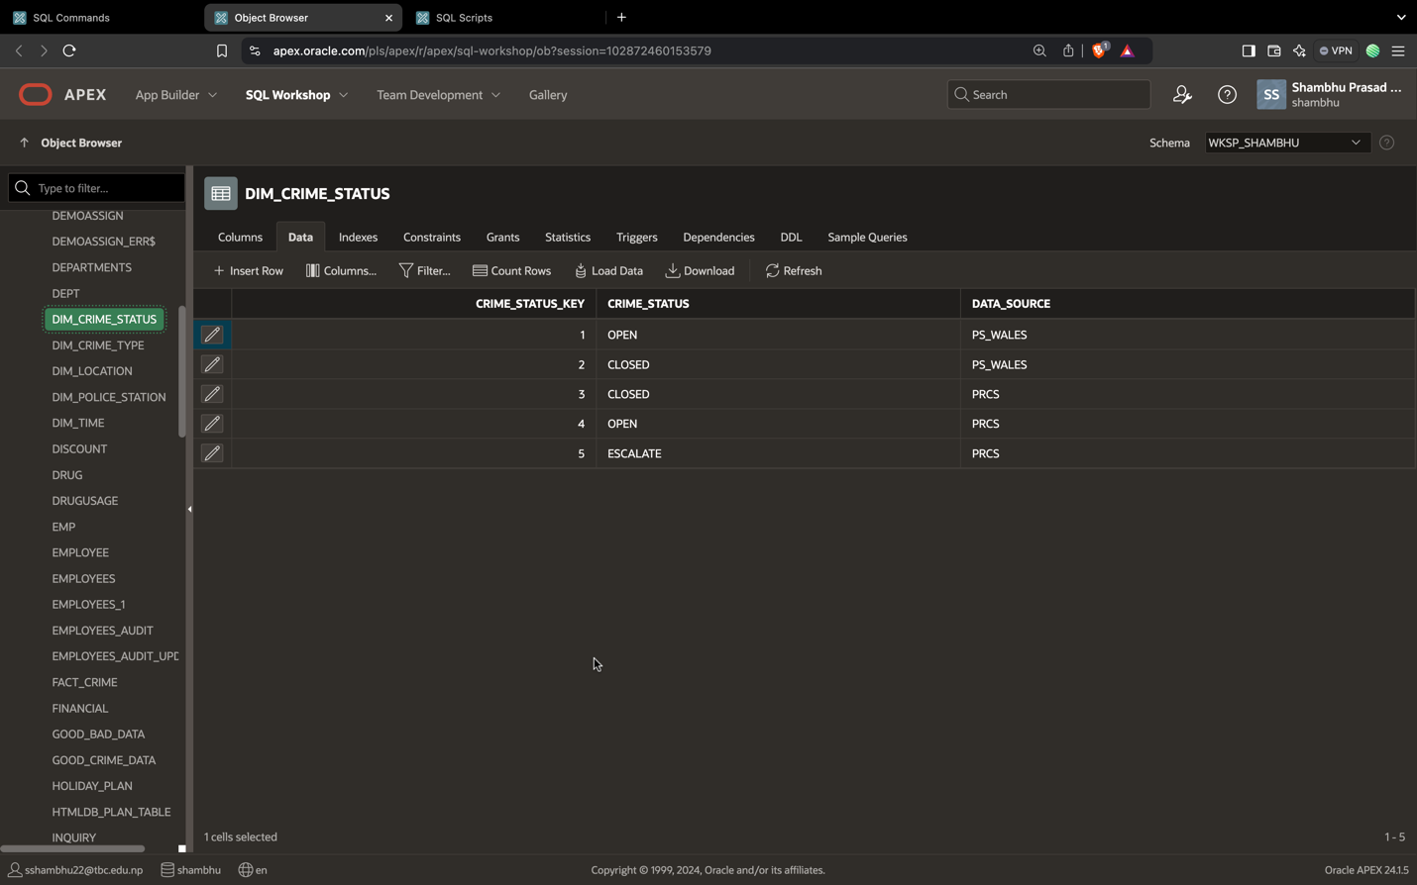

Data inserted into dim_crime_status.

**Fact Table Data**

Data from the fact table is populated from dim table and transformation table.  
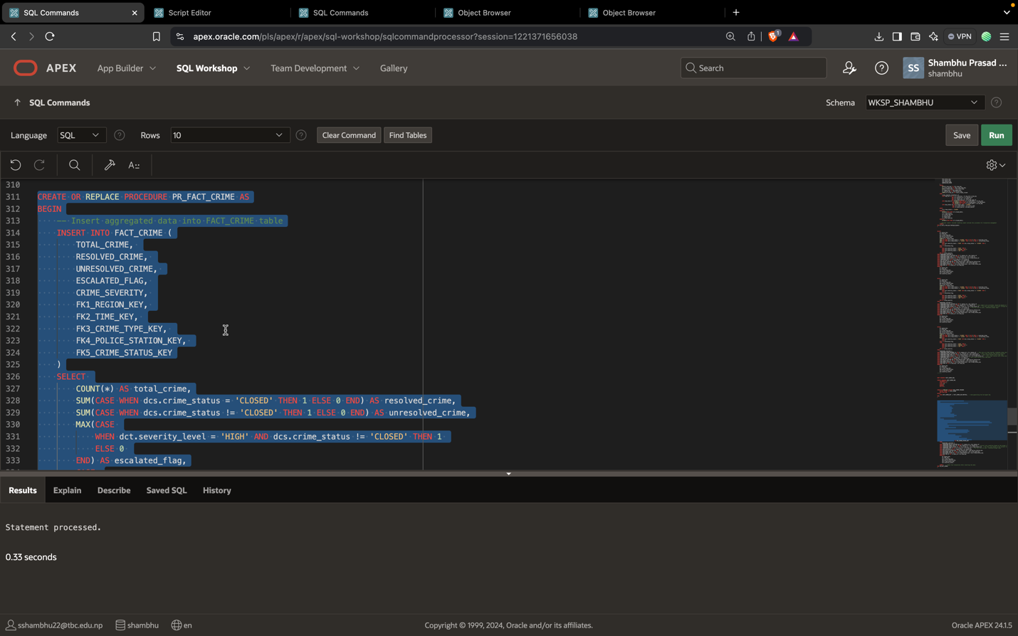

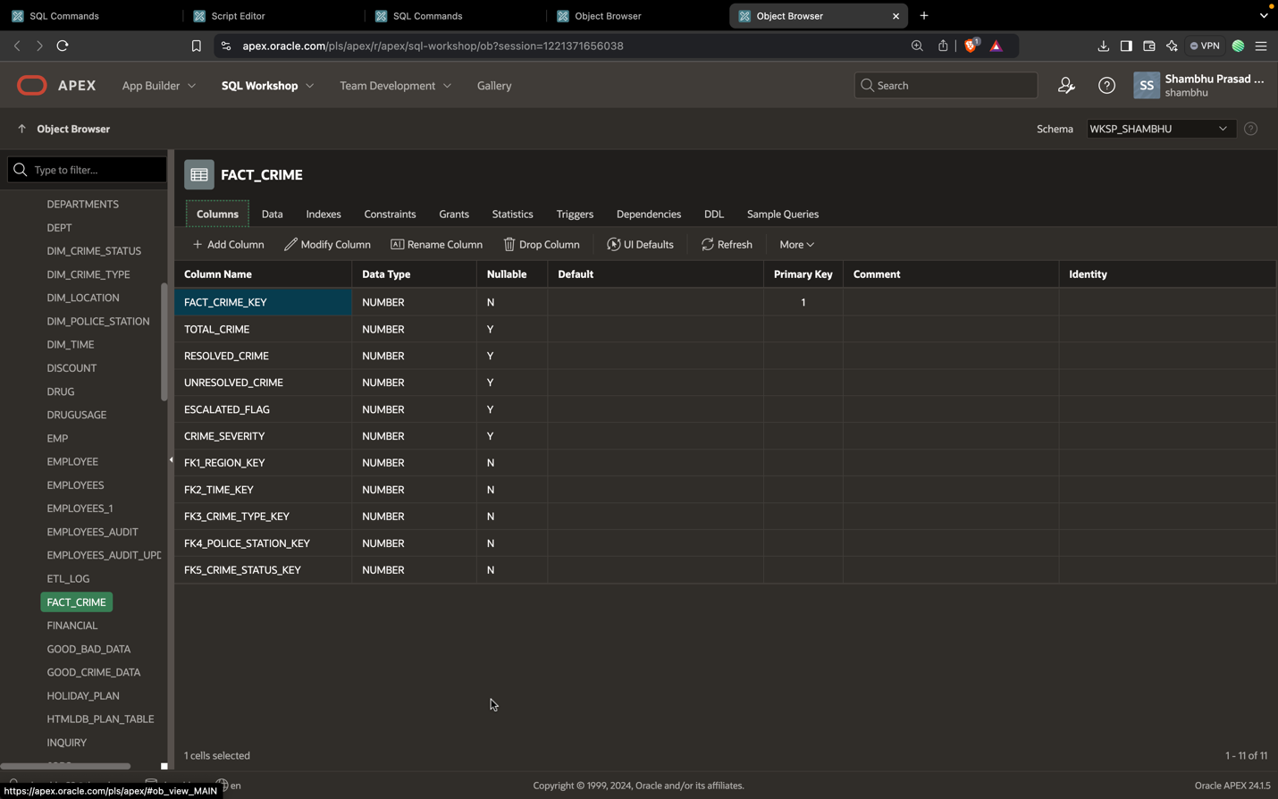

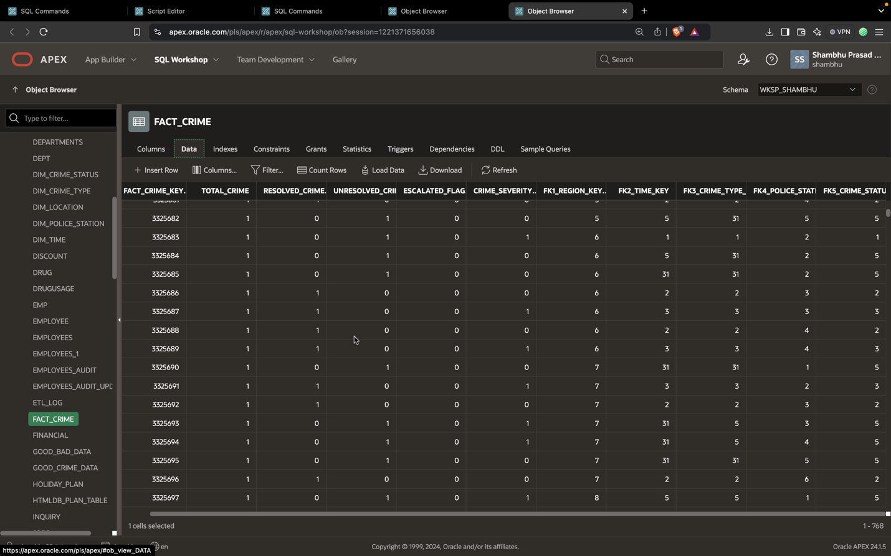

Data inserted into fact table.